Auditrix - A Curriculum Audit System for KSU

A Capstone Project Presented to the Faculty of the College of Engineering and Information Technology
in Kalinga State University

In Partial Fulfillment of the Requirements for the Degree Bachelor of Science in Information Technology

Jhonrey Binaraba
Crystel Mae Dela Cueva
Kenneth Christian Tockiapao

October 2026
ABSTRACT
DEDICATION
ACKNOWLEDGEMENTS
TABLE OF CONTENTS
TITLE PAGE . . . . . . . . . . . . . . . . . . . . . i
ABSTRACT . . . . . . . . . . . . . . . . . . . . . . ii
DEDICATION . . . . . . . . . . . . . . . . . . . . . iii
ACKNOWLEDGEMENTS . . . . . . . . . . . . . . . . . . iv
TABLE OF CONTENTS . . . . . . . . . . . . . . . . . . v
LIST OF TABLES . . . . . . . . . . . . . . . . . . . vi
LIST OF FIGURES . . . . . . . . . . . . . . . . . . . vii
CHAPTER 1. INTRODUCTION . . . . . . . . . . . . . . . 1
Background of the Study . . . . . . . . . . . . 1
State of the Art . . . . . . . . . . . . . . . . 7
Company Profile . . . . . . . . . . . . . . . . 8
Statement of the Problem . . . . . . . . . . . . 10
Objectives of the Study . . . . . . . . . . . . 11
Significance of the Study . . . . . . . . . . . 12
Scope and Delimitations . . . . . . . . . . . . 15
Definition of Terms . . . . . . . . . . . . . . 18
CHAPTER 2. REVIEW OF RELATED LITERATURE . . . . . . . 24
Global Literature . . . . . . . . . . . . . . . 24
Local Literature . . . . . . . . . . . . . . . . 30
CHAPTER 3. DESIGN AND METHODOLOGY . . . . . . . . . . 39
Software Development Methodology . . . . . . . . 39
Locale and Population of the Study . . . . . . . 45
Data Gathering Techniques . . . . . . . . . . . 46
Data Gathering Tools . . . . . . . . . . . . . . 47
Sources of the Data . . . . . . . . . . . . . . 48
Data Analysis . . . . . . . . . . . . . . . . . 49
Software Development Tools . . . . . . . . . . . 50
CHAPTER 4. RESULTS AND DISCUSSION . . . . . . . . . . 53
Process of the Existing System (SOP No. 1) . . . 53
Problems Encountered in the Current System
(SOP No. 2) . . . . . . . . . . . . . . . . . . 56
Narrative Description of the Proposed System
(SOP No. 3) . . . . . . . . . . . . . . . . . . 58
Features of the Proposed System . . . . . . . . 68
Input-Process-Output (IPO) Diagram of the
Proposed System . . . . . . . . . . . . . . . . 70
Non-Functional Requirements of the Proposed
System . . . . . . . . . . . . . . . . . . . . . 83
Testing of the System . . . . . . . . . . . . . 89
Extent of Compliance of the Proposed System
(SOP No. 4) . . . . . . . . . . . . . . . . . . 88
REFERENCES . . . . . . . . . . . . . . . . . . . . . 91
LIST OF TABLES
Table 4.1. Status of a Subject in the Student
Audit . . . . . . . . . . . . . . . . . . . . . . . . 60
Table 4.2. Year Level by Share of Curriculum
Units Passed . . . . . . . . . . . . . . . . . . . . 63
Table 4.3. Summary of the Automated Tests . . . . . . 90
Table 4.4. Extent of Compliance of Auditrix with
ISO/IEC 25010 . . . . . . . . . . . . . . . . . . . . 90
LIST OF FIGURES
Figure 1. Iterative and Incremental SDLC . . . . . . 40
Figure 4.1. Input-Process-Output Diagram of the
Existing System . . . . . . . . . . . . . . . . . . . 56
Figure 4.2. Ishikawa (Fishbone) Diagram of the
Problems in the Existing System . . . . . . . . . . . 58
Figure 4.3. Input-Process-Output Diagram of the
Proposed System . . . . . . . . . . . . . . . . . . . 70
Figure 4.4. Use Case Diagram of Auditrix . . . . . . 71
Figure 4.5. Activity Diagram for Curriculum
Audit . . . . . . . . . . . . . . . . . . . . . . . . 72
Figure 4.6. Menu Diagram of Auditrix . . . . . . . . 74
Figure 4.7. User Interface of Auditrix . . . . . . . 74
Figure 4.7a. Log In — Dean role . . . . . . . . . . . 75
Figure 4.7b. Log In — Program Chairperson role . . . 75
Figure 4.7c. Students — search and list view . . . . 76
Figure 4.7d. Student Audit — subject taken out of
order and Irregular status . . . . . . . . . . . . . 76
Figure 4.7e. Transfer / Shift Records . . . . . . . . 77
Figure 4.7f. Enter Grades — choosing the term . . . . 77
Figure 4.7g. Manage Curriculum Versions . . . . . . . 78
Figure 4.7h. Student Audit — status, term and
reason for each subject . . . . . . . . . . . . . . . 78
Figure 4.7i. Student Audit — fully compliant
(Regular) example . . . . . . . . . . . . . . . . . . 79
Figure 4.7j. Export Curriculum — PDF output . . . . . 79
Figure 4.7k. Create Program — new chairperson
account with a temporary password . . . . . . . . . . 80
Figure 4.7l. First Log In — password change with
the rules checklist . . . . . . . . . . . . . . . . . 80
Figure 4.7m. Dean Dashboard — Current semester . . . 81
Figure 4.7n. Chairperson Dashboard . . . . . . . . . 81
Figure 4.7o. Import Curriculum — preview of
changes . . . . . . . . . . . . . . . . . . . . . . . 82
Figure 4.7p. Grade Logbook . . . . . . . . . . . . . 82
Figure 4.7q. Edit Student — year level (automatic
or set by hand) . . . . . . . . . . . . . . . . . . . 83
Chapter 1
INTRODUCTION

Background of the Study
A Curriculum Audit system is defined as a systematic, technology-driven framework designed to audit student academic records against the official curriculum structure, ensuring compliance with prerequisite requirements and program sequencing (Alugar & Itaas, 2021). In higher education, curriculum auditing ensures that students follow the prescribed learning pathway, acquire foundational knowledge before advancing to higher-level courses, and meet graduation requirements.
Globally, universities have increasingly adopted automated systems and digital tools to strengthen academic monitoring, reduce human error, and improve efficiency in enrollment validation (Smith, 2020).
In the Philippine context, State Universities and Colleges (SUCs) are mandated to uphold quality assurance standards set by the Commission on Higher Education (CHED). These standards emphasize prerequisite compliance and curriculum integrity as part of outcomes-based education reforms introduced alongside the K to 12 transition (Largoza & Fernandez, 2025). However, despite the presence of Management Information Systems (MIS), many SUCs—including Kalinga State University (KSU)—continue to rely on manual processes for prerequisite validation. This reliance often results in the late detection of violations, sometimes only discovered during graduation evaluation, which can delay student completion and increase financial burdens (Miña et al., 2021).
Manual enrollment validation is particularly problematic in institutions with large student populations, where monitoring prerequisite compliance remains a significant administrative challenge. Currently, program chairpersons must manually review individual academic records to determine eligibility for specific subjects, a process that is notoriously time-consuming and prone to human error, especially within the compressed timeframe of a limited enrollment period. Espinosa, Serrano, & Balmes (2024) highlight that these manual inefficiencies not only burden administrators but also frustrate students, who may unknowingly enroll in courses without satisfying the necessary foundational requirements
Furthermore, the specific situation at Kalinga State University (KSU) illustrates how manual subject evaluation often leads to the late detection of prerequisite violations. In many cases, these critical errors are only uncovered during the final graduation audit, resulting in delayed program completion, increased financial costs, and the sudden prevention of students from graduating alongside their peers.
It is also observed that prerequisite checking within the university is frequently performed through traditional paper-based methods or legacy reviews, even with the existing Management Information System (MIS) in place. Consequently, many inconsistencies are not flagged immediately during the enrollment phase. These oversights typically surface during the final review of a candidate's academic history, creating a bottleneck that forces students to take additional semesters to satisfy missed requirements.
Another issue is that students are not always fully aware of the prerequisite requirements within their curriculum. Although students can view their academic records through the existing Management Information System, they may still enroll in subjects for which they have not satisfied the prerequisite requirements. This situation can lead to delays in academic completion.
Despite the availability of existing information systems, there is still a gap in automated tools that specifically focus on curriculum auditing and prerequisite validation. Many systems store student records, but do not automatically analyze whether a student's completed subjects follow the required curriculum structure. This gap highlights the need for a system that can automatically evaluate student records and identify prerequisite violations early in the academic process.
Automation offers a solution to these challenges. In the context of curriculum auditing, automation refers to the use of digital technologies to execute repetitive tasks, validate prerequisites, and generate compliance reports with minimal human intervention (Laudon & Laudon, 2022). Automated systems reduce manual workload, enhance accuracy, and improve transparency in academic management. They also provide real-time monitoring of student progress, enabling administrators to detect violations during enrollment rather than at graduation. Bagacay, Talatala, & Soberano (2024) demonstrate that automated registration systems streamline processes, reduce errors, and improve institutional efficiency, making them highly relevant to curriculum auditing.
Beyond efficiency, automation aligns with international standards for software quality. ISO/IEC 25010 provides a framework for evaluating systems in terms of functional suitability, reliability, usability, security, performance efficiency, compatibility, portability, safety, and maintainability (ISO, 2023). By adhering to these standards, universities can ensure that their systems meet institutional needs while also supporting accreditation and quality assurance. For KSU, adopting an automated curriculum audit system not only addresses current inefficiencies but also strengthens institutional readiness for external evaluation.
To address this issue, the proponents propose the development of a web-based application designed to assist in checking student academic records against the official curriculum. The system was designed to automatically detect prerequisite violations and to provide support to program chairpersons during enrollment by verifying whether students are eligible to enroll in specific subjects.
The primary goal of this study is to develop Auditrix - A Curriculum Audit System for KSU. The system was built to serve every college and program of Kalinga State University, and it was developed and tested with the BSCpE, BSIT, BSEE, BSMath, BSABE, and BSCE programs of the College of Engineering and Information Technology (CEIT). By checking each student's recorded grades against the curriculum version the student follows, the system detects prerequisite and co-requisite violations as soon as the grades are entered and shows which subjects each student may take next, so that ineligible subjects can be caught before enrollment rather than at graduation. Testing within the CEIT allowed the researchers to refine the audit rules using the college's actual curricula.
Although testing was done within the CEIT, the system is not limited to it. Colleges, programs, curriculum versions and staff accounts are records in the system rather than settings fixed in its code, so the other colleges of Kalinga State University (KSU) can use it once their deans create their programs and chairperson accounts. This project contributes to the modernization of academic management by providing an automated solution that reduces subject evaluation errors and enhances the efficiency of enrollment monitoring processes for the entire institution.
This study, therefore, proposes Auditrix - A Curriculum Audit System for KSU as a robust tool for enhancing curriculum integrity at Kalinga State University.
State of the Art
Auditrix introduced specialized functionalities designed to modernize academic auditing at Kalinga State University. The system's standout feature is its Audit Engine, which checks every subject a student has taken against its prerequisites, co-requisites, and year-standing requirements by comparing the term in which the subject was taken with the term in which each requirement was passed. Because the result is worked out from the terms every time a student's audit is shown, it does not depend on the order in which grades were encoded, and prerequisite violations that are often missed in manual reviews are flagged together with the reason, such as a prerequisite taken in the same term.
Since the system has no direct access to the university MIS, Auditrix imports student lists in the layout of the KSU-MIS "Export to Excel" file, and imports curricula from Excel (.xlsx or .xls) or CSV files with a preview of every change before it is saved. It also determines each student's year level from the units the student has passed, following the KSU Student Handbook and Operations Manual, classifies students as regular or irregular against the prescribed load of the current semester, and summarizes these on a dashboard for program chairpersons and deans.
Company Profile
SUC President
VP for Academic and Student Development

College Dean
Chairperson
Students

The organization involved in this study is Kalinga State University (KSU), located in Tabuk City, particularly in the Bulanao Campus, which serves as the main campus of the university. This is a public higher education institution that provides academic programs, research, and community services in the province of Kalinga. Kalinga State University started as the Kalinga Community College of Trade and Industries (KCCTI) in 1974. It was established through Resolution No. 97 by the Provincial Board of Kalinga-Apayao under Governor Rolando T. Puzon. The institution initially offered vocational courses such as poultry production, piggery, garments, trades, and native 100m weaving, with Augusto Alejandrino serving as its first administrator. The Municipal Council of Tabuk later allowed the college to use a portion of the Municipal Plaza as its campus.
The institution expanded its academic offerings by introducing a two-year Midwifery course, whose first batch of graduates achieved a 100% passing rate in the board examination. In 1978, additional programs in Liberal Arts, Commerce, Education, and Secretarial studies were introduced, which led to the renaming of the institution as Kalinga Community College.
In 1986, through Presidential Decree No. 2017, the Kalinga-Apayao State College (KASC) was created through the merger of several schools, although it officially became operational in 1992. In 1993, Francisco M. Basuel was appointed as the first president and introduced various academic programs, graduate degrees, infrastructure developments, and research initiatives.
Several presidents continued to strengthen the institution, including Venus I. Lammawin, Serafin L. Ngohayon, and Eduardo I. Bagtang, who expanded academic programs, facilities, research activities, and international collaborations.
In 2015, the institution achieved university status through Republic Act No. 7722 and officially became Kalinga State University, with Jovita E. Saguibo as its first university president. Today, the university continues to strengthen its academic programs, research initiatives, and community services.
Statement of the Problem
Despite the availability of a Management Information System (MIS), the lack of a specialized tool for automated curriculum monitoring forces the Program Chairperson to manually review student records, which creates a gap in institutional efficiency and data integrity.
Specifically, this study seeks to answer the following questions:
1. What are the current process for evaluating students’ prerequisite compliance with the curriculum?
2. What problems are encountered in evaluating students' prerequisite compliance with the curriculum?
3. How can a curriculum audit system be designed to ensure prerequisite compliance with the curriculum?
4. What is the level of compliance of the proposed system to ISO/IEC 25010 software quality standards in terms of functional suitability, usability, security, reliability, performance efficiency, compatibility, portability, maintainability, and safety?
Objectives of the Study
The primary goal of this study is to design and develop Auditrix: A Curriculum Audit System for KSU, a web-based tool for Kalinga State University, developed and tested in the College of Engineering and Information Technology (CEIT), that automatically validates student eligibility by checking finished subjects against curriculum standards.
- To identify the process for auditing the students' prerequisite compliance with the curriculum.
- To determine the problems encountered in auditing students' prerequisite compliance with the curriculum.
- To design and develop a system to ensure prerequisite compliance with the curriculum.
- To evaluate the level of compliance of the proposed system to ISO/IEC 25010 software quality standards in terms of functional suitability, usability, security, reliability, performance efficiency, compatibility, portability, maintainability, and safety.
Significance of the Study
The development of Auditrix represents a strategic shift toward modernizing the academic auditing framework of Kalinga State University. By transitioning from manual verification to an automated, data-driven approach, this study provides the following significant benefits:
Program Chairpersons. The system serves as a specialized administrative tool that transforms the evaluation of student eligibility from a manual task into an automated process. Once a student's grades are recorded, the system shows at once which subjects the student has completed, can take next, or took out of order, with the reason for each violation, removing the need to manually cross-reference records against the curriculum map. Student lists can also be imported from the KSU-MIS export instead of being typed in. This significantly reduces administrative workload, reduces human oversight, and allows chairpersons to dedicate more time with other functions.
College Dean. The study gives the Dean a reliable, college-wide picture of how well students in every program follow their curricula, without waiting for each chairperson's manual report. With this information, the Dean can recognize early which programs have many irregular students or prerequisite violations, decide where academic advising or a curriculum review is needed, and plan the offering of subjects and the assignment of faculty accordingly. Because only authorized personnel can access student records, the college's academic data are kept secure and confidential. The consistent, documented audit records also serve as evidence of the college's commitment to academic integrity and outcomes-based education during AACCUP accreditation and CHED monitoring visits.
Students. While the Program Chairperson is the primary user, students are the ultimate beneficiaries of the system’s precision. By ensuring that prerequisite violations are flagged as soon as grades are recorded, and that the subjects a student is not yet eligible for are visible to the chairperson before enrollment, the system protects students from the academic and emotional distress of being barred from graduation due to late-discovered delinquencies. This proactive approach minimizes unnecessary financial burdens and ensures a seamless, on-time pathway toward program completion.
University Administration. Auditrix provides a centralized and highly accurate platform for monitoring institutional curriculum compliance. By maintaining strict data integrity and adhering to CHED standards regarding prerequisite sequencing, the university strengthens its position during quality assurance audits and institutional accreditation. Furthermore, the system supports evidence-based governance by providing clear, real-time insights into student progression and identifying potential curriculum bottlenecks.
Future Researchers. This study establishes a technical and conceptual foundation for further innovations in educational technology. It serves as a validated reference for developing more advanced academic tools, such as predictive analytics for student success or the integration of AI-driven decision support systems within higher education institutions in the Philippines.
Scope and Delimitations
The primary focus of this study is the design and development of Auditrix: A Curriculum Audit System for Kalinga State University (KSU). The system is engineered as a specialized administrative tool to support Program Chairpersons in monitoring student curriculum progress and ensuring strict prerequisite compliance.
Although the system was built for all thirteen (13) colleges of the university, this study focuses on the College of Engineering and Information Technology, which served as the primary data source and testing site; the system was tested with the curricula and students of the BSMath, BSEE, BSCpE, BSIT, BSABE, and BSCE programs.
The system covers several key functionalities designed to automate and analyze academic progression. At its core, the software records grades through a term-based grade entry module, in which a term is written as the school year and semester (for example, 25-1 for the first semester of School Year 2025-2026, and 26-S for the midyear after its second semester, as on KSU records), and checks them against the program's curriculum, which is maintained in versions per curriculum year. Each subject on a student's record is assigned one of five statuses: Completed, Available, Pending, Unavailable, or Violation. A Violation is determined from the terms: a prerequisite must have been passed in a term before the subject was taken, and co-requisites must be taken and passed in the same term. Because the statuses are worked out again each time a record is viewed, grades can be entered in any order, and a violation is cleared only when the subject is retaken after its requirements are met. The system also keeps a record of student movement through a transfer, shift, and drop module, which logs every case in a per-student history; the record of a dropped or transferred-out student is locked against changes until it is reopened.
Beyond basic auditing, the system includes a dashboard that summarizes each program: the total number of students, the regular and irregular students, the students with violations, the curriculum versions, and the number of students who shifted, transferred, or dropped. Its charts show the students per year level (Freshman to Senior) and the subjects most often taken out of order. A "Needs attention" list points the chairperson to the students who need action, and the Dean can compare the programs of the college side by side.
Year levels are determined automatically from what each student has finished, following the KSU Student Handbook and Operations Manual: a student moves up when the share of curriculum units passed reaches the threshold for Sophomore (25%), Junior (more than 50%), or Senior (75%), or when every subject of the earlier years has been passed. A student is classified as regular when enrolled in the full prescribed load for the current semester and irregular when enrolled in less, as defined in the same manual. Incomplete (INC) grades are shown as Pending until the chairperson enters the final grade; an INC does not lapse automatically into a failing grade.
The system does not include subsystems for other administrative offices, such as the Registrar, Accounting, or Library services. It does not enroll students in subjects; it audits recorded grades and reports each subject's status. It is not connected to the KSU MIS or to the Registrar's records: student lists and curricula are encoded or imported from files (Excel or CSV), and grades are entered student by student. Students do not have their own access to the system.
The system's logic is limited to descriptive auditing (identifying compliance with existing rules) and does not include predictive analytics (forecasting of program completion) or AI-driven enrollment counseling, and it does not monitor graduation or residency limits.
Definition of Terms
This section explains the technical terms used in this study. For each term, different sources are evaluated, and their relevance as applicable to this study is provided.
Curriculum Audit System. Refers to the web-based system designed and developed in this study to analyze student academic records and compare them with the official curriculum. Its primary purpose is to detect prerequisite violations for use by Program Chairpersons and Deans.
Prerequisite. A course that must be successfully completed before a student can enroll in a more advanced subject. In this study, following the KSU Student Handbook, a prerequisite must be passed in a term before the term in which the subject is taken; prerequisites are validated automatically to ensure students follow the correct program sequence.
Prerequisite Violation. A situation where a student takes a subject without having passed its prerequisite in an earlier term, or without taking its co-requisite in the same term. Auditrix flags such a subject with the status Violation and states the reason; the subject earns no credit and must be retaken.
Completed. One of the five statuses a subject can have in the student audit. A subject is Completed when the student has passed it and the pass counts, because the subject was taken only after its requirements had been met.
Available. A status meaning that the student may take the subject now because its requirements have been met, or must take it again because it was failed or taken out of order.
Pending. A status meaning that the subject cannot be decided yet: it is in progress, it has an INC grade, or it is waiting for the final grade of another subject.
Unavailable. A status meaning that the student has not yet met the subject's requirements and cannot take it yet; the missing requirements are listed (e.g., "Needs: CC 104").
Violation. A status meaning that the subject was taken before one of its requirements was met, for example, before its prerequisite was passed. Auditrix states the reason; the subject earns no credit and must be retaken.
Co-requisite. A subject that must be taken simultaneously with another, in the same semester (KSU Student Handbook). In this study, co-requisites pair both ways, must be taken in the same term, and must both be passed; if one is failed, both are retaken.
Incomplete (INC). A grade given when a student has not yet completed the requirements of a subject. In Auditrix, a subject with an INC is shown as Pending, and it counts as passed only from the term in which the final grade was given.
Term. A semester of a school year, written in Auditrix as YY-S: the first two digits of the school year and the semester (1 for the first semester, 2 for the second semester, and S for the midyear). As on KSU records, a midyear carries the year of the semester after it, so terms are ordered 25-1, 25-2, 26-S, then 26-1.
Year Level. The classification of a student as Freshman, Sophomore, Junior or Senior. In this study, it is determined from the share of the curriculum's units the student has passed, following the KSU Student Handbook (2020 edition) and the KSU Operations Manual: Student Development Services & Placement Guide.
Year Standing. A requirement of some subjects (for example, "Third year standing") that is met by being on that year level when the subject is taken.
Regular Student. A student who is enrolled in the full prescribed academic load in a given semester of the curriculum in which he or she is enrolled (Kalinga State University, 2020). In Auditrix, the prescribed load is the curriculum's subjects for the student's year level and the current semester, not counting subjects already passed.
Irregular Student. A student who is enrolled in less than the prescribed academic load in a given semester of the curriculum in which he or she is enrolled (Kalinga State University, 2020). Auditrix lists the prescribed subjects that the student is missing.
Current Semester. The term a college is currently in, set by the Dean in Auditrix. Year levels and the regular or irregular status of students are worked out relative to it.
Management Information System (MIS). A computerized system used by KSU to manage student academic records. Auditrix is not connected to the MIS; instead, it accepts the student list file produced by the MIS's "Export to Excel" function.
Data Export. The function that allows the Program Chairperson to export a curriculum version to an external file format, CSV or PDF, for archiving or physical documentation.
Automated Analytics Dashboard. A visual interface that provides an immediate, graphical summary of student progress and curriculum compliance, allowing the Chairperson and the Dean to analyze program-wide data at a glance.
ISO/IEC 25010 Software Quality Standards. An international framework used to evaluate the quality of Auditrix. The system is to be evaluated based on nine characteristics: functional suitability, performance efficiency, compatibility, usability, reliability, security, maintainability, portability, and safety.
Chapter 2
REVIEW OF RELATED LITERATURE
This chapter presents the relevant literature reviewed and evaluated by the researchers that helped them conceptualize their study. The review is organized into global and local sections.
Global Literature
The integration of information technology has fundamentally evolved the management of academic curricula. Jovanović and Dimitrijević (2023) developed a higher education curriculum management system that addresses the complexities of coordinating curriculum development and tracking student progress. Their research emphasizes the importance of centralized database architecture to manage teaching processes and curriculum modifications efficiently, highlighting the necessity of systematic curriculum oversight.
Parallel to this, the global landscape of quality assurance in higher education has been extensively studied, particularly regarding accreditation processes. Saeed et al. (2021) conducted a comprehensive review of sustainable program assessment practices, focusing on ABET and NCAAA accreditation processes for computer information systems programs. Their findings emphasize that measurement for program assessments requires systematic information systems to satisfy international accreditation standards.
Furthering this digital transformation, Akulova et al. (2025) developed an information system for accreditation and assessment in education, presenting a management information system specifically designed for educational accreditation. The system architecture includes structured functions for managing specialist training program accreditation, demonstrating the feasibility of digital transformation in accreditation processes.
Practical applications of these systems show significant results, as seen at United Arab Emirates University, which implemented a Learning Outcomes Assessment Management System (LOAMS) to streamline academic quality assurance processes (Al-Fedaghi & Al-Muhanna, 2022). The system features role-based user privileges, automated workflow management, and infographics for tracking assessment status. Since its deployment in 2018, LOAMS has successfully managed learning outcomes assessment for over 1,000 courses per semester, proving the scalability and effectiveness of web-based audit systems.
Addressing administrative challenges, Salleh et al. (2020) developed an Accreditation Document Tracking System (ADTS) using the Scrum approach to monitor document movement and timelines. The system addresses critical challenges in document control, including dislocation and timeline oversight, by providing web-based tracking capabilities. Similarly, Taufiqurrahman et al. (2025) created a web-based accreditation system for study program management using the Waterfall model. The system incorporates role-based access for administrators, program heads, and assessors, with features including structured document uploads and dashboard visualizations, achieving 100% success rates in black-box testing.
Standardization also plays a key role, as Oware and Mokoena (2025) developed a framework for institutional audit quality in Ghanaian universities to address systematic implementation challenges. Their comparative analysis of international models, including Australia's TEQSA and New Zealand's Academic Quality Agency, revealed that standardized audit frameworks with defined domains and assessment scales significantly improve audit effectiveness.
Innovative methodologies have also emerged, with the Quality Assurance Agency for Higher Education (QAA) in the United Kingdom documenting curriculum audit methodologies in 2024, including curriculum blueprinting and design sprints. These case studies demonstrate how structured audit processes can accelerate program approval; for example, De Montfort University successfully approved over 75 undergraduate programs in less than three months using streamlined audit workflows.
Evaluative research further supports these advancements. Sadhana and Freire (2025) designed and evaluated a web-based student learning outcome assessment system for secondary education, utilizing the Waterfall model and Unified Modeling Language. Their evaluation achieved "very high" feasibility scores across usability (88.5%) and functional reliability (90.5%). Similarly, Gunawan et al. (2023) developed a web-based dashboard system for monitoring study program accreditation instruments at Universitas Pendidikan Ganesha, Indonesia, which achieved excellent efficiency and dependability scores based on User Experience Questionnaire benchmarks.
Finally, recent literature highlights the proliferation of commercial curriculum management software. Akari Software (2023) documented systems providing centralized platforms for curriculum mapping and learning outcome assessment, enabling institutions to streamline accreditation through comprehensive reporting. Watermark Planning & Self-Study (2025) offers integrated assessment and accreditation management solutions that allow institutions to align assessment plans with strategic goals and manage self-studies collaboratively, supporting continuous improvement through real-time data analysis.
The reviewed literature establishes a global consensus on the critical role of specialized information systems in modernizing academic governance and quality assurance. Research by Jovanović and Dimitrijević (2023) and Akari Software (2023) highlights that centralized database architectures are essential for managing the inherent complexities of curriculum development and student progression tracking. This shift toward digital transformation is further supported by Akulova et al. (2025) and Saeed et al. (2021), who argue that systematic information systems are no longer optional but are a technical necessity for meeting international accreditation standards such as ABET and NCAAA.
A recurring theme across these studies is the effectiveness of web-based platforms in streamlining administrative workflows. The successful deployment of systems like LOAMS at United Arab Emirates University (Al-Fedaghi & Al-Muhanna, 2022) and the ADTS document tracker (Salleh et al., 2020) demonstrates that automated auditing can handle large-scale data while reducing human error and oversight. Furthermore, the integration of dashboard visualizations and real-time monitoring, as evidenced by the works of Taufiqurrahman et al. (2025) and Gunawan et al. (2023), provides administrators with actionable insights that enhance institutional efficiency and dependability.
Finally, the literature emphasizes that structured audit frameworks significantly improve the speed and quality of academic processes. Case studies from the QAA in the United Kingdom (2024) and standardized models in Ghana (Oware & Mokoena, 2025) reveal that moving away from legacy reviews toward streamlined, technology-driven methodologies allows institutions to maintain high quality standards even under compressed timelines. Collectively, these studies validate the development of Auditrix as a timely intervention that aligns with global best practices in automated curriculum validation, accreditation readiness, and continuous institutional improvement.
Local Literature
The Commission on Higher Education (CHED) has initiated significant digital transformation efforts to enhance regulatory processes. The Philippine Institute for Development Studies (2024) reported that CHED has begun piloting a digital regulatory system designed to streamline the submission and processing of accreditation and certification documents. The system implements step-by-step digital screening where final submissions are only accepted upon completion of all required steps, significantly improving efficiency and transparency in regulatory compliance.
Complementing these efforts, the World Bank (2023) documented the Institutional Sustainability Assessment (ISA) framework implemented by CHED. This includes a Self-Evaluation Document (SED) that higher education institutions use to assess institutional sustainability across five key result areas: governance and management, quality of teaching and learning, quality of professional exposure and research, support for students, and relations with the community. Miranda and Reyes-Chua (2021) examined best practices in quality assurance in selected higher education institutions in the Philippines using the Malcolm Baldrige framework. Their study found that highly implemented quality assurance practices were strongly related to the accreditation levels of private institutions, emphasizing the importance of systematic quality management systems.
Further evidence of this trend is seen in Prado (2025), who evaluated the quality assurance practices of College of Education programs in a Philippine local university. The study found that continuous quality assurance systems—especially accreditation—serve not only to maintain standards but also to drive institutional improvement, highlighting the need for integrated information systems to support quality assurance processes. However, Santelices and De La Cruz (2023) examined quality assurance in the certification procedure of the Regional Quality Assessment Team for higher education institutions in Region V, Philippines. Their research noted that no single quality assurance framework can address all quality dimensions, suggesting the need for localized, flexible audit systems.
The CHED Handbook on Typology, Outcomes-Based Education, and Institutional Sustainability Assessment (2014, updated through 2024) provides the foundational framework for OBE implementation in Philippine higher education. The handbook details curriculum mapping processes, program outcomes development, and assessment methodologies that align with international standards while addressing local contextual needs. Miano and Baguio (2024) conducted research on the application of curriculum mapping in relation to classroom learning outcomes in public elementary schools in Governor Generoso, Division of Davao Oriental. Their study found a significant relationship between curriculum mapping application and classroom learning outcomes, demonstrating that systematic curriculum mapping improves educational effectiveness.
Briones (2019) examined the implementation of Outcomes-Based Education in state universities in Region I, Philippines. Findings revealed that a majority of respondents were compliant with OBE minimum requirements and highly compliant in terms of alignment and consistency of the learning environment. Nevertheless, research on SUC quality assurance systems (2025) highlighted that Philippine State Universities and Colleges face significant challenges in maintaining program accreditation and obtaining Certificates of Program Compliance (COPC) set by CHED. Despite mandates to implement quality management systems under ISO 2015, many institutions struggle with continuous program accreditation requirements, indicating the need for enhanced digital audit systems.
Specific programmatic challenges also persist, as research on Outcomes-Based Education implementation in maternal and child nursing programs in the Philippines (2024) identified the need for harmonization of macro and micro curriculum, comprehensive faculty training, and stronger administrative support. The study emphasized that curriculum mapping is essential for ensuring alignment between institutional vision and program outcomes. In response to these needs, Surigao State College of Technology (2025) documented their General Education Program Curriculum Map, illustrating the relationship between courses and program educational outcomes, while Guimaras State University (2025) documented comprehensive quality assurance activities including regular internal audits and mock accreditation exercises.
These local initiatives are supported by the legal framework of the Education Act of 1982 (Batas Pambansa Blg. 232) and CMO No. 46, Series of 2012, which seek to improve quality assurance through outcomes-based and typology-based systems tailored to the institution. However, recent studies on enrollment information systems in the Southern Philippines (2024) revealed critical recommendations for improving processes such as room allocation, faculty availability, and student advising, recommending the development of Enrollment Portals to allow students to manage enrollment processes independently while supporting academic timetable coordination and curriculum revisions.
The literature demonstrates a clear global trend toward digitizing curriculum and accreditation management processes. Studies by Jovanović and Dimitrijević (2023), Xiaoyan et al. (2023), Akulova et al. (2025), and Taufiqurrahman et al. (2025) consistently support the implementation of web-based systems with centralized database architectures for managing academic processes. The success of LOAMS at UAE University (Al-Fedaghi & Al-Muhanna, 2022) and the accreditation systems developed in Indonesia (Gunawan et al., 2023) provide empirical evidence that such systems can scale to manage thousands of courses and users effectively.
In the Philippine context, CHED's digital transformation initiatives (PIDS, 2024; World Bank, 2023) establish the policy foundation for curriculum audit systems. However, local institutions still struggle with manual processes and fragmented systems, as documented by studies on SUC quality assurance challenges (2025) and enrollment system limitations (2024). Global literature emphasizes the importance of integrating audit systems with established quality assurance frameworks. Oware and Mokoena's (2025) standardized framework and the QAA's (2024) innovative curriculum audit methodologies demonstrate that effective audit systems must align with international standards while accommodating local contextual needs. In the Philippine setting, CHED's ISA framework, AACCUP accreditation standards, and the ASEAN University Network quality assurance standards provide the regulatory foundation for curriculum audit systems.
The research by Miranda and Reyes-Chua (2021) and Prado (2025) confirms that Philippine institutions require integrated systems that can simultaneously address local accreditation requirements (AACCUP, CHED COPC) while maintaining alignment with international standards. Both global and local literature identify common pain points in manual curriculum and accreditation management. Salleh et al. (2020) and Taufiqurrahman et al. (2025) documented challenges including document dislocation, timeline oversight, and fragmented assessment data. Philippine studies similarly highlight manual processing delays, lack of real-time monitoring, and difficulties in maintaining CHED compliance (PIDS, 2024; Necosia & Sealza, 2024; SUC quality assurance studies, 2025).
Auditrix directly addresses these identified gaps through automated prerequisite checking, real-time audit status for every student, centralized curriculum and grade data, and audit trails (a grade logbook and a per-version curriculum change history) that respond to the specific need for transparency and accountability in both global quality assurance literature and local regulatory requirements. The literature consistently emphasizes the shift toward outcomes-based education (OBE) and the corresponding need for assessment management systems. Saeed et al. (2021), Sadhana and Freire (2025), and Gunawan et al. (2023) demonstrated that effective OBE implementation requires systematic tracking of learning outcomes, course outcomes, and program outcomes. The Philippine higher education sector's mandatory adoption of OBE frameworks, as documented in CHED policies (CHED Handbook, 2014/2024), Briones (2019), Miano and Baguio (2024), and nursing education studies (2024), creates a specific local need for systems that can map curriculum components to learning outcomes and generate compliance reports.
While existing literature provides extensive coverage of general accreditation systems and learning management systems, there remains a specific gap in comprehensive curriculum audit systems that integrate curriculum mapping, accreditation tracking, and quality assurance in a unified platform. Most existing systems focus on either document management (Salleh et al., 2020) or learning outcome assessment (Al-Fedaghi & Al-Muhanna, 2022) but lack the holistic approach to curriculum auditing that examines alignment between planned, delivered, and assessed curricula. Auditrix contributes to filling part of this gap by offering a curriculum-specific audit system designed for a Philippine state university: it checks every student's record against the prerequisite, co-requisite and year-standing rules of the student's curriculum version, following the KSU Student Handbook and Operations Manual, while incorporating global best practices in curriculum management and automated checking.
Chapter 3
DESIGN AND METHODOLOGY
This chapter outlines the systematic approach and technical procedures utilized by the researchers in the development and evaluation of Auditrix: A Curriculum Audit System for Kalinga State University. It provides a comprehensive discussion of the research design, the setting of the study, the participants involved, the software development phases, and the statistical tools used to interpret the evaluation data.
Software Development Methodology
To ensure a structured yet adaptive development process, the researchers adopted the Iterative and Incremental Development (IID) model. Unlike the traditional linear approach, this methodology allowed the proponents to develop Auditrix through a series of repeated cycles (iterations), where each cycle resulted in a functional "increment" or version of the software. This approach is selected because it enables the researchers to validate the "Audit Engine" logic with the Program Chairpersons early in the process and refine features based on actual administrative feedback before the final deployment.

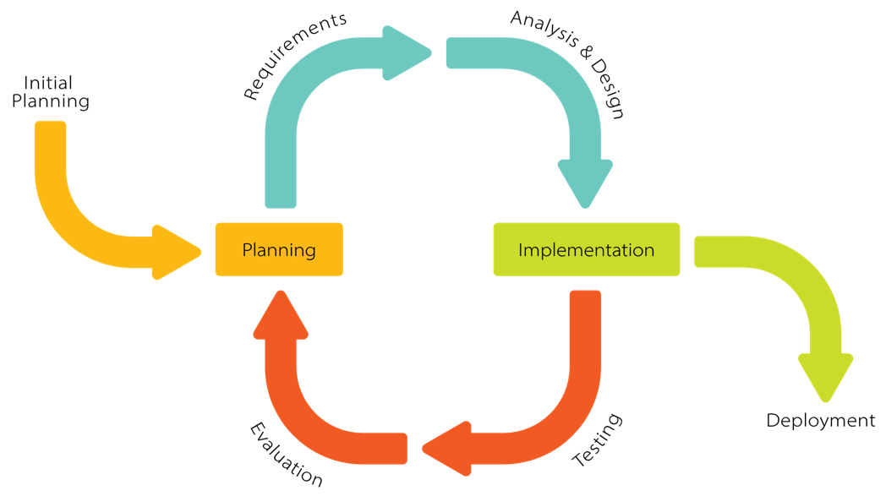

Figure 1. Iterative and Incremental SDLC
Initial Planning
The study begins with a comprehensive investigation to validate existing challenges within the curriculum auditing process at KSU-CEIT. This stage involves the distribution of structured data-gathering tools and the conduct of preliminary interviews with the six program chairpersons to formally identify manual bottlenecks and administrative pain points in curriculum evaluation. These high-level insights establish the project's foundation and overall goals before entering the first development cycle.

Planning and Requirements Phase
At the start of each iteration, the researchers define specific functional goals and translate stakeholder needs into technical requirements. This involves identifying the particular "increment" to be built, such as the core audit logic or the reporting dashboard. Detailed requirements are documented to ensure that each version of the software addresses a specific administrative burden while maintaining alignment with the overall project objectives.
Analysis and Design Phase
During this phase, requirements are translated into technical blueprints that evolve with each iteration. The researchers use the Iterative and Incremental Development model to guide the cycles of planning, design, implementation, and testing, and an Ishikawa (fishbone) diagram to analyze the causes of the problems found in the existing system. Input-Process-Output (IPO) diagrams describe what the existing and the proposed systems take in, process, and produce. The database is designed in Supabase through an entity-relationship diagram (ERD) that defines the tables, their keys, and their relationships, with row-level security policies that limit each role to its own program or college. The behavior of the system is modeled with a use case diagram of the actors and what each of them can do, an activity diagram that serves as the flowchart of the audit of a subject, and a menu diagram of the system's navigation. High-fidelity user interface mockups are created in Figma, prioritizing a responsive "Command Center" dashboard using Tailwind CSS, so that the interface remains intuitive and seamless as new features, such as the curriculum and student import modules, are added.
The Audit Engine is designed around three algorithms. The first audits each subject by comparing the term in which the subject was taken with the terms in which its requirements were passed, and assigns one of five statuses: Completed, Available, Pending, Unavailable, or Violation. The second computes a student's year level from the share of the curriculum's units passed before the current semester. The third classifies a student as regular or irregular by comparing the subjects the student is enrolled in with the prescribed load for the current semester.
Implementation
The actual coding of Auditrix takes place using Next.js with React and TypeScript, with development divided into three functional increments. The first increment (July 2026) produced the core of the system: curriculum management, student registration, grade entry and a basic audit of prerequisites. The second increment (August to September 2026) added curriculum versions, deans and colleges, shifting, transfers and drops, curriculum and student imports with an import preview, a redesign of the user interface, the first-login password change, and the curriculum change history. The third increment (late September to October 2026) replaced the first prerequisite checker with a term-based one that also covers co-requisites and INC grades, and added the current semester, automatic year levels, the regular and irregular classification, support for Excel files, protection against an earlier-term grade replacing a later one, the marking of subjects in progress, midyear terms written as on KSU records, locked records for dropped and transferred-out students, dashboard charts with a Student Movements page, and security measures such as a database-enforced audit trail, role checks on every page and automatic sign-out. Each increment results in a functional version of the software that builds upon the previous one.

Testing Phase
As each increment is completed, it undergoes rigorous verification to ensure technical reliability. This includes unit testing of the audit rules and the other modules, and integration testing of the server actions, both written with the built-in test runner of Node.js; and functional (end-to-end) testing, in which a web browser is scripted with Playwright to log in as a dean and as chairpersons and use each feature on a local copy of the full system. The researchers also perform "negative testing" by entering invalid grades, malformed terms and student ID numbers, and incorrectly formatted import files to verify that the system rejects them with a reason, and by entering the same grades in different orders to verify that the audit flags the same subjects as Violation regardless of the order of entry, and by opening the pages of another role to verify that access is refused.
Evaluation Phase
The final stage involves a formal assessment of the integrated system using the ISO/IEC 25010 Software Quality Model to determine its readiness for institutional use. This evaluation is conducted by Program Chairpersons and IT experts via a paper-based questionnaire to provide a balanced view of the software’s functional suitability, usability, and security. Feedback from this phase confirms whether the system has successfully met the goals defined during the initial planning.
Deployment Phase
Once the system has passed all evaluation criteria and reached full functionality, it is prepared for deployment. This final exit point of the model marks the transition of Auditrix from a development project to a live tool ready for use by the deans and program chairpersons of the College of Engineering and Information Technology, and later of the other colleges. At the time of writing, the system runs on a local server; its deployment to a hosted (online) server is yet to be done.
Locale and Population of the Study
The study was localized within the Kalinga State University (KSU) – Main Campus, specifically at the College of Engineering and Information Technology (CEIT).
The participants were purposively selected based on their direct involvement in the enrollment and auditing processes at Kalinga State University. This group includes the six Program Chairpersons of the CEIT, who provided the domain expertise necessary to ensure the system’s logic aligns with actual university policies and prerequisite standards. To capture the technical perspective, IT experts were engaged to provide a rigorous critique of the system’s architecture, security protocols, and compliance with international software standards. Additionally, the study included students who have personally experienced prerequisite violations; these individuals provided critical data via Google Form regarding the real-world impact of manual auditing errors on their academic progression. By integrating feedback from administrators, technical experts, and the affected student body, the researchers ensured a comprehensive validation of the system’s functional and institutional requirements.
Data Gathering Techniques
The researchers employed a multi-stage data gathering strategy to ensure the technical accuracy and functional relevance of the system:
Document Analysis. The researchers meticulously reviewed official university documents, including the KSU-CEIT curriculum maps, the KSU Student Handbook, the KSU Operations Manual: Student Development Services & Placement Guide, and CHED-mandated prerequisite sequences. The Student Handbook's definitions of prerequisite, co-requisite and Incomplete (INC) grades, and the Operations Manual's classification of year levels and of regular and irregular students, served as the foundational logic for programming the Audit Engine.
Survey (ISO/IEC 25010). Upon the completion of the system, a formal evaluation was conducted using a printed (paper-based) questionnaire structured around the ISO/IEC 25010 framework. This questionnaire was distributed to both the Program Chairpersons and IT Experts to evaluate the software’s functional suitability, usability, security, and performance efficiency.

Data Gathering Tools
The researchers utilized the following data gathering tools to ensure a comprehensive data collection process:
Survey Questionnaire
A standardized survey questionnaire based on the ISO/IEC 25010 software quality model will be used to gather quantitative data from the respondents. This instrument will evaluate the developed system based on the following criteria:
- Functional Suitability (Audit Engine, grade entry, and violation flagging)
- Reliability (consistent audit results regardless of the order of entry; validated imports)
- Performance Efficiency (loading time of the audit and the dashboard)
- Usability and Security (dashboard, student audit page, role-based access and password policy)
- Compatibility
- Maintainability
- Portability
- Safety

Sources of the Data
The information required for this study was derived from two distinct categories to ensure both practical and technical validation. The primary sources of data consisted of the six Program Chairpersons of the CEIT and selected IT experts, who provided domain expertise and technical evaluation scores, as well as students who have personally experienced prerequisite violations and offered direct feedback regarding the deficiencies of the manual auditing process. Supplementing these human sources were secondary data points, which included official Kalinga State University curriculum maps, student handbooks, and class lists exported from the KSU Management Information System (MIS), in the format provided by the Program Chairpersons. The format for importing curricula was designed by the researchers. By synthesizing the qualitative insights from these participants with the quantitative benchmarks found in existing institutional literature and automated academic auditing records, the researchers established a comprehensive data foundation for the development and evaluation of the proposed system.
Data Analysis
The data gathered from the evaluation will be analyzed using the Weighted Mean. This statistical method will allow the researchers to calculate the average response for each ISO characteristic, providing a clear numerical value that represents the overall quality of the Auditrix system. These findings will then be used to justify the system's capability to replace or enhance the current manual processes at Kalinga State University.
Software Development Tools
To ensure the development of a robust, secure, and highly responsive application, the researchers utilized a specialized "Full-Stack" technology suite. Each tool in this stack has been selected for its ability to handle complex academic data and provide a seamless administrative experience:
Next.js (React Framework). This served as the primary development framework for Auditrix. Its server-side rendering (SSR) and server actions allowed for high-performance UI rendering and efficient server-side logic. This ensured that the Chairperson could process large volumes of student records without experiencing system lag.
Tailwind CSS. This utility-first CSS framework was used to design a professional, "Command Center" style dashboard. It ensured that the system was fully mobile-responsive, allowing the user to access the auditing tools across various devices, including desktop computers, tablets, and smartphones, without compromising the layout or functionality.
Supabase. The researchers utilized Supabase as the backend-as-a-service (BaaS) provider. It hosted the PostgreSQL database for the secure storage of student records, grades and curriculum maps. Furthermore, it managed the system's user authentication and enforced row-level security policies, so that each chairperson can reach only their own program's data, to ensure that sensitive academic information was protected.
Figma. During the design phase, Figma was employed as the primary prototyping tool. The researchers created high-fidelity wireframes and interactive mockups to visualize the user flow and interface layout. This ensured that the system's design was validated for usability before the actual implementation (coding) phase began.
TypeScript. The system was written in TypeScript, which adds type checking to JavaScript. The audit rules are kept in a separate module of plain TypeScript code with no framework code, so that they can be tested on their own.
@react-pdf/renderer. This library was used to produce the PDF export of a curriculum version.
Node.js Test Runner and Playwright. The automated tests were written with the test runner built into Node.js, and Playwright was used to script a web browser for the functional (end-to-end) testing of the system.
Git and GitHub. The source code was kept under version control with Git and stored on GitHub, so that each version of the system is controlled.
Chapter 4
RESULTS AND DISCUSSION
This chapter presents the analysis, presentation, discussion, and findings of the study gathered by the researchers. Data collected from the six (6) Program Chairpersons of the College of Engineering and Information Technology (CEIT), selected IT experts, and students who experienced prerequisite violations are systematically organized, interpreted, and analyzed. The presentation of results corresponds directly to the Statement of the Problem: (1) the current process for evaluating students' prerequisite compliance with the curriculum, (2) the problems encountered in that process, (3) the design of a curriculum audit system to ensure prerequisite compliance, and (4) the level of compliance of the proposed system, Auditrix, to the ISO/IEC 25010 software quality standard. The results of the testing done on the developed system are presented before SOP No. 4.
Process of the Existing System
Based on data gathered through preliminary structured interviews with the six (6) Program Chairpersons at KSU-CEIT, the current mechanism for evaluating student prerequisite compliance remains predominantly dependent on decentralized, manual methods. Kalinga State University maintains a central Management Information System (MIS) that stores historical final grades and manages registration data; however, this MIS was not built to analyze whether a student's completed subjects actually follow the prescribed curriculum sequence. As a result, prerequisite checking still relies on traditional paper-based or legacy cross-referencing even with the MIS in place, and inconsistencies are frequently not flagged during the enrollment phase itself.
During the enrollment period, the manual curriculum audit process operates as follows:
Digital Subject Selection. Students access the MIS portal to initiate enrollment and select the subjects they wish to add. Many students use the "Enroll All" button, which automatically queues every available subject into a pending status without validating historical grades against prerequisite or corequisite requirements. Because students can view their own records but are not proactively warned about ineligibility, they may select subjects they are not yet qualified to take.
Manual Record Auditing. The Program Chairperson must then manually open each pending enrollment request, going through the student's record line-by-line and cross-referencing completed courses and passing marks (≤3.00) against the physical curriculum map or program checklist.
Human Error and Validation. The Chairperson attempts to filter out subjects before finalizing the enrollment data. Because this process is repetitive and constrained by a compressed timeline, human error is unavoidable, allowing prerequisite violations to go undetected for a period of time or until the final graduation audit — a bottleneck that forces affected students into additional semesters to satisfy missed requirements.
[INPUT] | [PROCESS] | [OUTPUT]
- Student Historical Grades on MIS Portal. | - Automated queuing of unverified subjects via "Enroll all" option | - Approved or Finalized Enrollment Assessment.
- Official KSU-CEIT Curriculum map. | - Line-by-line manual audit of pending registrations against passing records | - Undetected Prerequisite Violations in the System
- Pending Unverified Subject Enrollee logs. | - Human error filtration slips during manual check | - Late-discovered violations surfacing after enrolment closing or at graduation audit
Figure 4.1. Input-Process-Output Diagram of the Existing System
Problems Encountered in the Current System
The structural reliance on manual human review within a compressed timeline creates operational vulnerabilities. Data drawn from the assessment tools highlight three critical administrative issues:
1. Late-Detection Blindspots. Because the current MIS does not enforce structural blocks during digital enrollment selection, prerequisite violations frequently go unnoticed. These discrepancies are often discovered years later or during the final graduation audit, forcing senior students into unexpected residency extensions and additional financial strain.
2. Absence of Automated Compliance-Checking Tools. While the MIS reliably stores student grades and registration records, it has no built-in logic to cross-reference a student's completed subjects against the official curriculum structure. This places the entire burden of compliance verification on the Chairperson's manual review rather than on the system itself, leaving no automated safeguard between data entry and eligibility determination.
3. Limited Student Awareness of Prerequisite Requirements. Although students can view their own academic records through the MIS, the system does not proactively alert them when they are ineligible for a subject. Students may therefore unknowingly attempt to enroll in courses without having completed the necessary prerequisites, adding to the volume of cases the Chairperson must catch downstream.
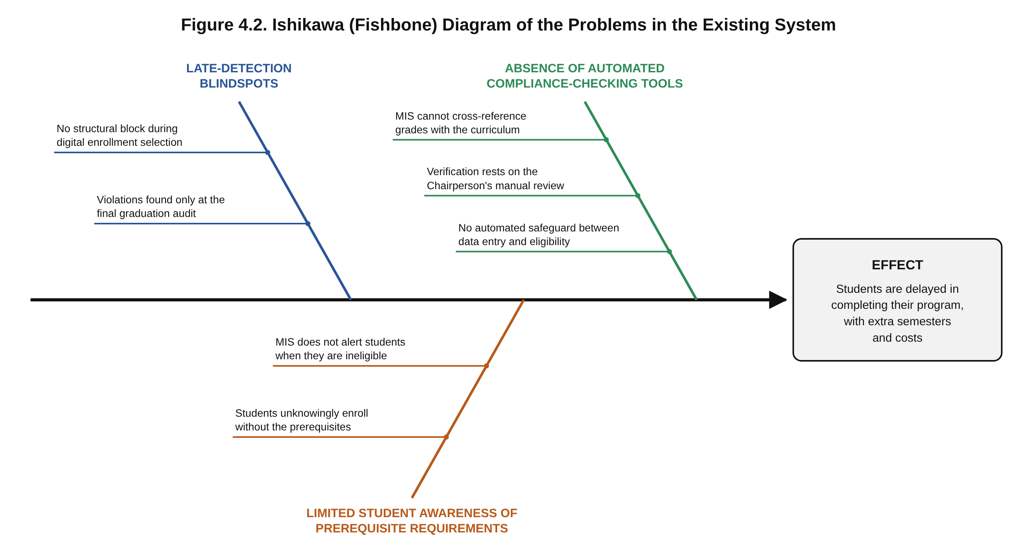
Figure 4.2 presents these three problems in an Ishikawa (fishbone) diagram, with each problem as a branch and its causes listed under it: Late-Detection Blindspots (no structural block during digital enrollment selection; violations found only at the final graduation audit), Absence of Automated Compliance-Checking Tools (the MIS cannot cross-reference grades with the curriculum; verification rests on the Chairperson's manual review; no automated safeguard between data entry and eligibility), and Limited Student Awareness of Prerequisite Requirements (the MIS does not alert students when they are ineligible; students unknowingly enroll without the prerequisites). Together, they lead to the same effect: students who are delayed in completing their program, with extra semesters and costs.
Narrative Description of the Proposed System
To address the gaps identified above, the researchers designed and developed Auditrix, a web-based curriculum audit system for Kalinga State University that automatically checks every subject a student has taken against the prerequisites, co-requisites, and year-standing requirements of the student's curriculum. It was built for any college and program, and was tested with the BSCpE, BSIT, and BSCE programs of the CEIT. The system was built using the Iterative and Incremental Development (IID) model, allowing the Audit Engine's logic to be reviewed early and refined across three functional increments: (1) curriculum, student and grade records with a basic audit; (2) curriculum versions, imports, student movements and the redesigned interface; and (3) the term-based audit, automatic year levels, and the regular and irregular classification.
The system runs on Next.js 16 (App Router and server actions) with React 19 and TypeScript, styled with Tailwind CSS 4 in a KSU green theme designed for responsiveness across desktop, tablet, and mobile. Supabase serves as the backend-as-a-service, hosting the PostgreSQL database, authentication, and Row-Level Security (RLS) policies; the database schema is built step by step by 30 migration scripts. Curricula are exported to PDF with @react-pdf/renderer. Interface flows were prototyped as high-fidelity mockups in Figma prior to implementation.
At the core of Auditrix is a TypeScript-based audit engine that checks every subject of the student's curriculum against the student's grade records and gives each subject one of five statuses, shown in Table 4.1 together with the subject's grade and the term in which it was taken:
Status | Meaning
Completed | Passed, and the pass counts because the subject was taken in order.
Available | Can be taken now because its requirements are met, or must be retaken because it was failed or taken out of order.
Pending | In progress, INC, or waiting for another subject's final grade.
Unavailable | Requirements not met yet; the missing ones are listed (e.g., "Needs: CC 104").
Violation | Taken before a requirement was met; the reason is given (e.g., "CC 101 was taken in the same term (24-1)").
Table 4.1. Status of a Subject in the Student Audit
The statuses are not stored at the moment a grade is entered. Instead, every time a student's audit is shown, the engine compares the term in which each subject was taken with the term in which each of its requirements was passed. Because of this, grades can be encoded in any order and the result stays the same, and a violation remains on the student's record until the subject is retaken after its requirements are met. This design replaced the system's first checker, which stored a permanent flag at the moment of entry; the reasons for the change are discussed under Testing of the System.
The engine evaluates four requirement types — prerequisite, co-requisite, year standing, and "all subjects completed" — closing the exact gap identified in SOP 1 and 2, where the existing MIS had no equivalent logic. The rules it follows, and their sources, are described below.
Terms are written as on KSU records: the first two digits of the school year and the semester (1 for the first semester, 2 for the second, and S for the midyear). A midyear carries the year of the semester after it, so terms are ordered 25-1, 25-2, 26-S (midyear), then 26-1.
The KSU Student Handbook requires a prerequisite to be passed prior to taking a subject and nullifies the credit of a subject taken without it. Accordingly, a prerequisite must be passed in a term before the term in which the subject was taken; passing it in the same term is a violation. Taking a subject while its prerequisite is still INC is also a violation, since an INC counts as passed only from the term in which it was resolved. A subject taken out of order earns no credit: it does not satisfy later prerequisites, does not count toward units or year level, and has to be retaken. If a prerequisite's grade from an earlier term is still in progress, the subject is Pending rather than a violation.
Co-requisites. The Student Handbook defines co-requisites as subjects taken simultaneously, in the same semester. In Auditrix, they pair both ways, even when only one of the two subjects lists the other. Both must be taken in the same term; taking only one of them, or taking them in different terms, is a violation. If one is failed, neither counts and both are retaken.
Year level. Following the KSU Student Handbook (2020 edition) and the KSU Operations Manual, which specifies that a student's year level should follow what the student has finished in the curriculum, the year level is computed from the share of the curriculum's units passed, as shown in Table 4.2. Passing every subject of the earlier years also moves a student up, even if the units fall slightly short. Only passes that count, and only those earned before the current semester, are included, so students move up when the Dean moves the college to a new semester. The year level given at registration or import is used as a starting point until the grades show more, and a chairperson can set a year level by hand for a special case and set it back to automatic.
Year level | Share of the curriculum's units passed
1st year (Freshman) | Less than 25%
2nd year (Sophomore) | 25% to 50%
3rd year (Junior) | More than 50% (exactly 50% stays 2nd year)
4th year (Senior) | 75% or more
Table 4.2. Year Level by Share of Curriculum Units Passed
Year standing. A year-standing requirement (e.g., "Third year standing") is met by being on that year level. For a subject already taken, the engine uses the student's year level going into that term, counting only what was passed before it. When nothing was recorded for that term, and the grades alone do not show the standing, for example, because older grades have not been encoded yet, the subject is marked "Year standing: please verify" (in amber) instead of being flagged as a violation.
Regular and irregular students. Per the Student Handbook and the Operations Manual, a student is regular when enrolled in the full prescribed load for the current semester, and irregular when enrolled in less; the missing subjects are listed. The prescribed load is taken to be the curriculum's subjects for the student's year level and the current semester, not counting subjects already passed in an earlier term, and back subjects taken on top of a full load do not make a student irregular. Enrollment is known from the grades (or "in progress" records) of the current semester; with nothing recorded, the status is "Not determined," and the student is not counted either way. At the start of a semester, the chairperson marks the subjects each student is taking as In progress, so the status is known before any grades come in.
Grade entry. Grades are entered per term for the subjects of a chosen curriculum year and semester, starting on the current semester. Only valid KSU grades are accepted: 1.0, 1.25, 1.5, 1.75, 2.0, 2.25, 2.5, 2.75, and 3.0 (passing), 5.0 (failing), and INC, and a subject the student is taking this semester can be marked In progress. Several subjects can be ticked and marked In progress at once; ticking all leaves out the subjects the student cannot take yet (e.g., "Can't take yet. Needs: MATH 111"), which can still be ticked one by one if the student is enrolled in them anyway. Only changed grades are saved, and changing an existing grade is treated as a correction that asks for confirmation. A final grade for an INC keeps the subject in the term it was taken and records the term in which the INC was resolved (shown as "INC → 25-1"). Since only the latest attempt of a subject is kept as the student's record, a grade from an earlier term than the recorded one is refused unless the chairperson confirms that it corrects a wrongly entered term. After saving, a message names any subject that has just become a violation, and every grade ever entered is kept in the student's grade logbook together with who entered it and when. The database writes this logbook itself, so its entries cannot be edited or deleted, and it accepts only KSU grades that match their status and well-formed terms.
Curriculum Management. Each program keeps curriculum versions by effective year (e.g., BSCpE 2019 and 2023), and a new version can copy an existing one. Each subject has a code, title, units, year level and semester (including midyear), and its requirements. Curricula can be imported from an Excel (.xlsx or .xls) or CSV file, in a format designed by the researchers, with a preview of what will be added, changed or removed before saving, exported to CSV or PDF, and every change is kept in a per-version change history showing who changed what, and when.
Students and Student Movements. Students are registered one at a time or imported from an Excel (.xlsx or .xls) or CSV file, either the system's template or a class list exported from the KSU MIS (its "Export to Excel" file, in the format the Program Chairpersons provided), and ID numbers are checked against the KSU format (e.g., 24-113792). When a student shifts, the releasing chairperson files a shift request and the receiving program's chairperson accepts the student into one of their curriculum versions. Transfers in and out and drops are recorded as well, and every movement is kept in the student's history. Marking a student as dropped or transferred out locks the record: the database refuses changes to the student's grades, details and year level until the chairperson reopens the record, which is also kept in the history. A Student Movements page lists every shift, transfer, drop and reopening, with search and filters. The student list can be searched from the top bar of any page and filtered by year level, curriculum version and status, and the reason for each student's status is shown under the name (e.g., "Out of order: PHYS 201").
Dashboard. A "Needs attention" banner at the top lists what to act on, such as students with violations, students with nothing recorded for the current semester, or an unset semester, each linked to the matching filtered student list. Per program, the dashboard shows the total number of students, the regular and irregular students (and how many are not yet determined), the students with violations, the curriculum versions, and the number of shifts, transfers and drops. Four charts are built only from recorded data: regular, irregular and not determined students; students by year level from Freshman to Senior; bottleneck subjects, where the most students' latest grade is 5.0 or INC; and the subjects most often taken out of order. Each chart has a short explanation, shows the exact numbers on hover, and can be viewed as a table. The Dean sets the current semester from the dashboard and compares the programs of the college side by side, but does not open individual students' records, which remain the chairperson's work.
Access control and data scoping. Supabase RLS scopes visibility by role: Program Chairpersons see only the data of their own program, while Deans see their whole college. Operations that must all succeed together, such as creating a program with its chairperson account, replacing a chairperson, or accepting a shifting student, run as single database transactions. A new chairperson receives a temporary password from the Dean and must choose their own at first login, guided by a checklist that ticks each password rule as it is met, and actions that are hard to undo, such as dropping a student or saving grades, ask for confirmation first. Every page checks the user's role, so a page meant for another role cannot be opened by typing its address; users are signed out after 30 minutes without activity; and an account is blocked for 15 minutes after five wrong passwords.
Features of the Proposed System
- Role-based login for Deans and Chairpersons, with a required password change at first login
- Term-based Audit Engine checking prerequisites, co-requisites, year standing and "all subjects completed"
- Student registration and import from Excel or CSV (the template or the KSU-MIS "Export to Excel" file)
- Student list with search from any page, filters and the reason for each student's status, and an audit page showing each subject's status, grade, term and the reason for any violation
- Term-based grade entry with KSU grade values, In progress marking for several subjects at once, INC completion, earlier-term protection and a database-written grade logbook
- Curriculum management with versioning (e.g., BSCpE 2019 vs. BSCpE 2023), change history, and import with preview
- Shift requests and shift-ins, transfers and drops, with a per-student history, locked records for dropped and transferred-out students, and a Student Movements page
- Automatic year levels with chairperson override, and regular/irregular classification
- Dashboard per program with a Needs attention banner and charts, a side-by-side program comparison for the Dean, and the current semester set by the Dean
- Export of curriculum versions to CSV or PDF
- Security: role checks on every page, row-level security, a database-enforced audit trail, sign-out after 30 minutes of inactivity, and blocking after repeated wrong passwords
Scope boundaries. The system does not include subsystems for the Registrar, Accounting, or Library, and it is not connected to the KSU MIS. Its logic is limited to descriptive auditing (identifying compliance with existing rules); it does not perform predictive analytics, graduation monitoring, or AI-driven enrollment counseling.
Input-Process-Output (IPO) Diagram of the Proposed System
[INPUT] | [PROCESS] | [OUTPUT]
- Student lists (registered, or imported from Excel/CSV or the KSU-MIS export) | - Term-based audit of every subject against its requirements | - Status per subject (Completed / Available / Pending / Unavailable / Violation) with reasons
- Versioned curriculum: subjects with their prerequisites, co-requisites and year-standing requirements | - Year level from units passed; regular / irregular from the prescribed load | - Violations flagged as soon as grades are saved; subjects available for the next enrollment
- Grades per term (including INC and its resolution), the current semester, and shifts, transfers and drops | - Role-scoped review via RLS (Chairperson by program, Dean by college) | - Dashboard counts and charts, grade logbook, student movements, and curriculum CSV / PDF exports
Figure 4.3. Input-Process-Output Diagram of the Proposed System
Figure 4.4 shows the two actors of the system. The Program Chairperson interacts with most modules: managing curriculum versions (including their import and export), registering and importing students, entering grades, viewing each student's audit and grade logbook, setting a year level by hand, recording shifts, transfers and drops, and reopening a locked record. The Dean oversees the college: viewing the dashboard of every program and comparing the programs, setting the current semester, creating programs with their chairperson accounts, reassigning chairpersons, and splitting the college by moving some of its programs to a new college with its own dean. Both log in, view a dashboard and the Student Movements page, and change their password, and a new chairperson must replace the temporary password at first login. The audit itself needs no separate action: the system performs it whenever a student's audit or the dashboard is shown.
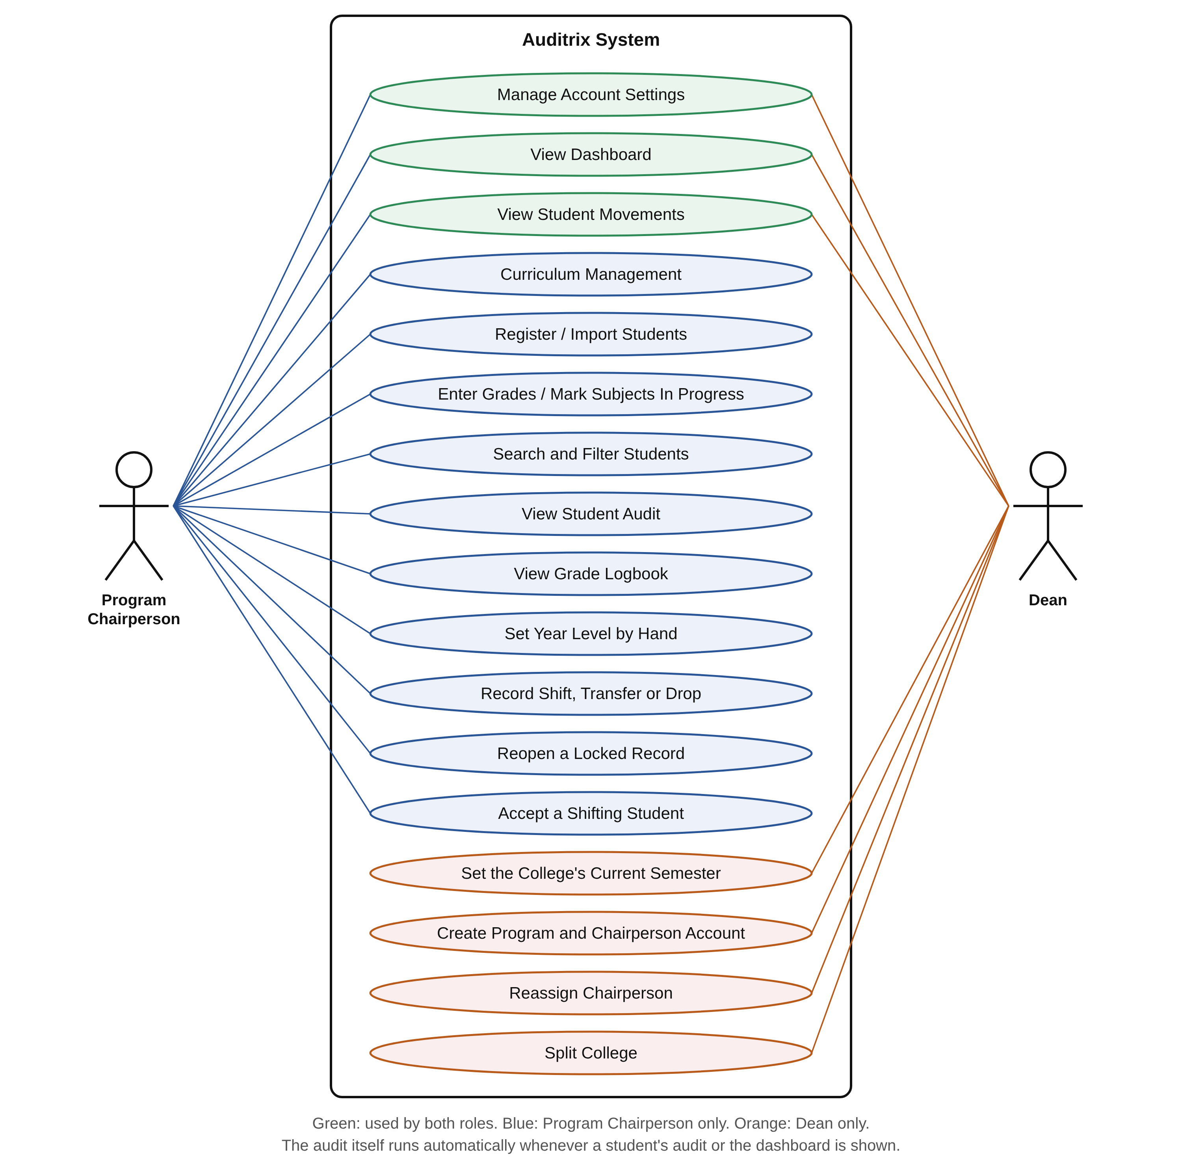
Figure 4.4. Use Case Diagram of Auditrix
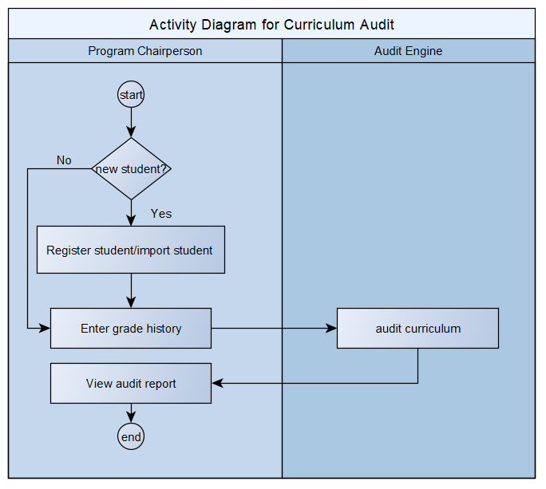
Figure 4.5. Activity Diagram for Curriculum Audit
Figure 4.5 shows the activity diagram for the curriculum audit, divided into two swimlanes: the Program Chairperson and the Audit Engine. The process starts with the chairperson checking whether the student is new. A new student is first registered or imported from a student list, while an existing student's record is used as it is. The chairperson then enters the student's grade history, which is passed to the Audit Engine. The Audit Engine audits the record against the student's curriculum, comparing the term in which each subject was taken with the terms in which its requirements were met, and gives each subject one of the five statuses in Table 4.1. The result returns to the chairperson as the student's audit report, which ends the process.
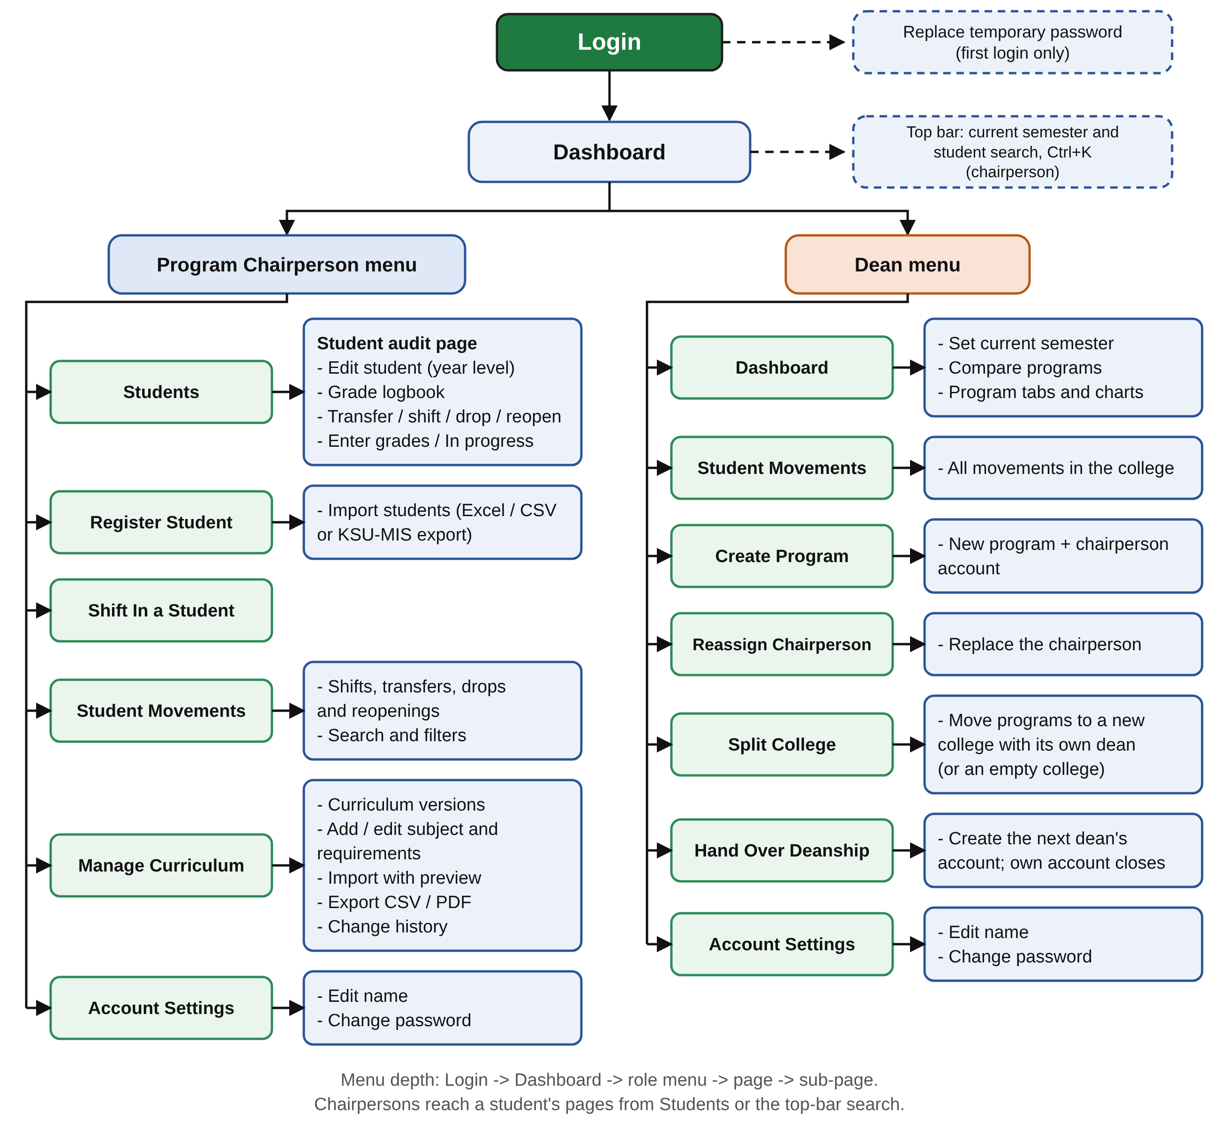
Figure 4.6. Menu Diagram of Auditrix
Figure 4.6 outlines the system's navigation. From Login (and the password change required at a chairperson's first login), users land on the Dashboard. A Program Chairperson's menu leads to Students, Register Student, Shift In a Student, Student Movements, Manage Curriculum and Account Settings, and a student search is available from the top bar of every page; from Students, each student's audit page opens the Edit Student, Grade Logbook, Transfer / Shift, and Enter Grades pages. A Dean's menu leads to the Dashboard, where the current semester is set and the programs are compared, Student Movements, Create Program, Reassign Chairperson, Split College, Hand Over Deanship and Account Settings. Split College moves some of the college's programs to a new college with its own dean, and Hand Over Deanship creates the account of the next dean and closes the outgoing dean's account. In Account Settings, both roles can edit their name and change their password.
Figure 4.7. User Interface of Auditrix
Figure 4.7 shows the main screens of the developed system, captured from the running application with sample CEIT data.
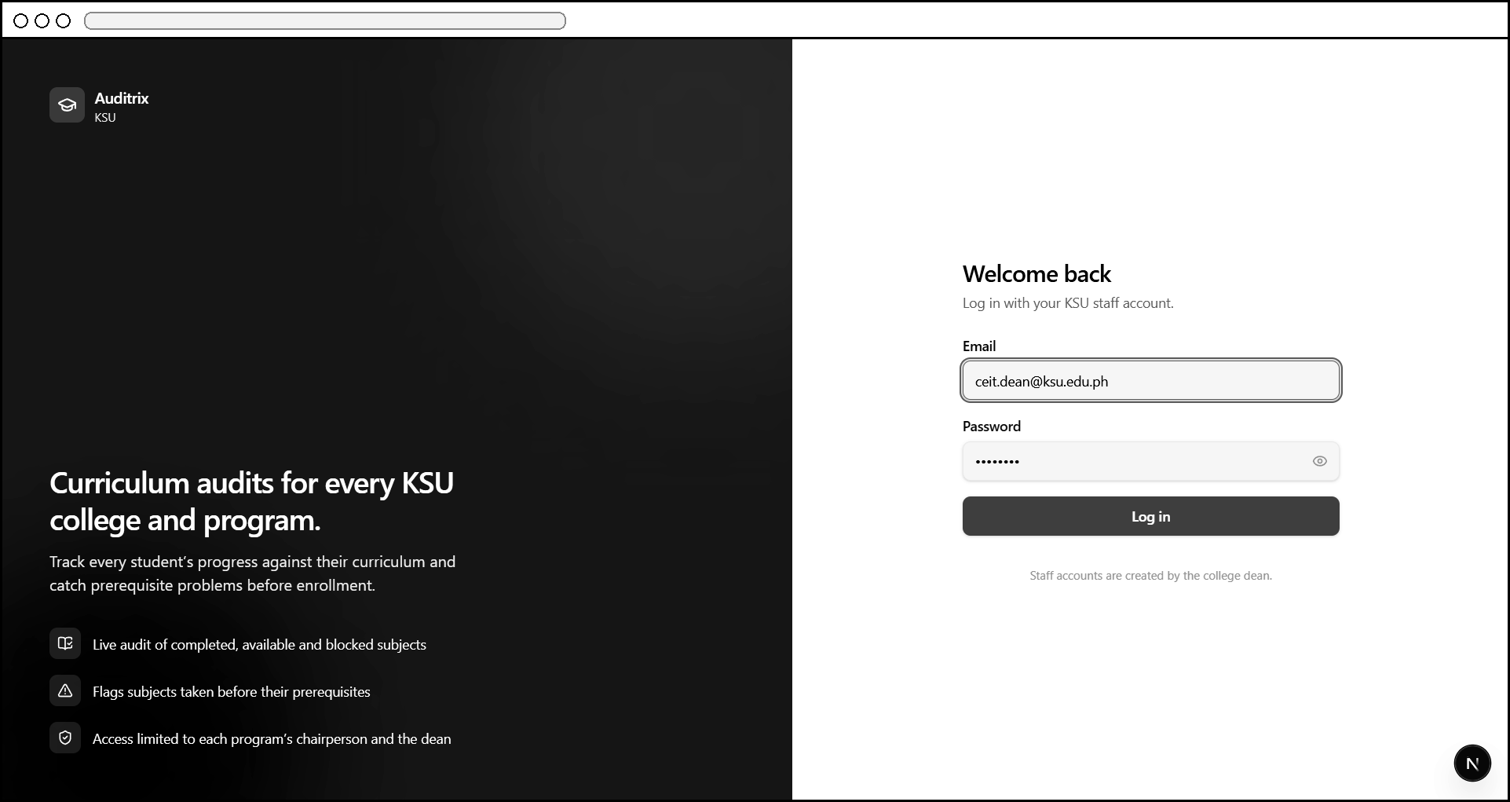
Figure 4.7a. Log In — Dean role
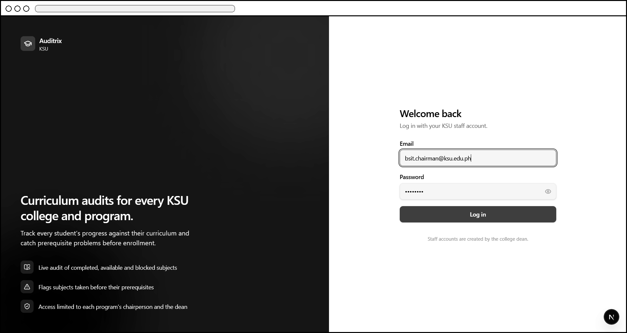
Figure 4.7b. Log In — Program Chairperson role
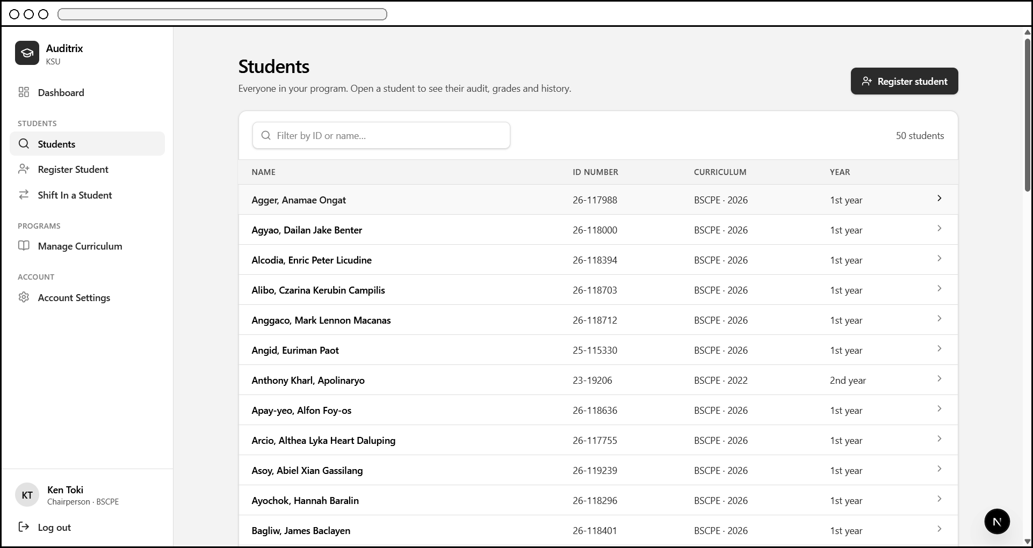
Figure 4.7c. Students — search and list view
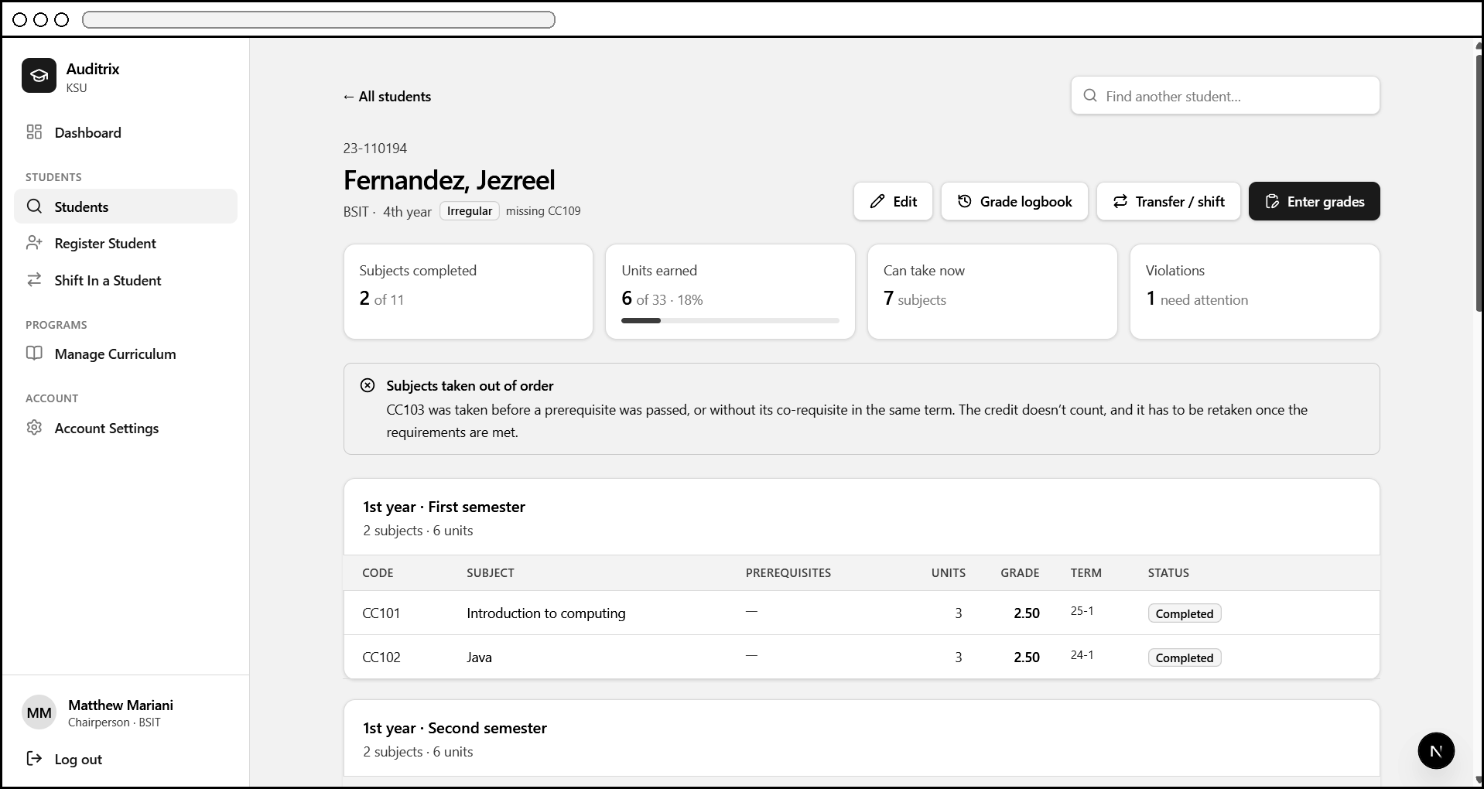
Figure 4.7d. Student Audit — subject taken out of order and Irregular status
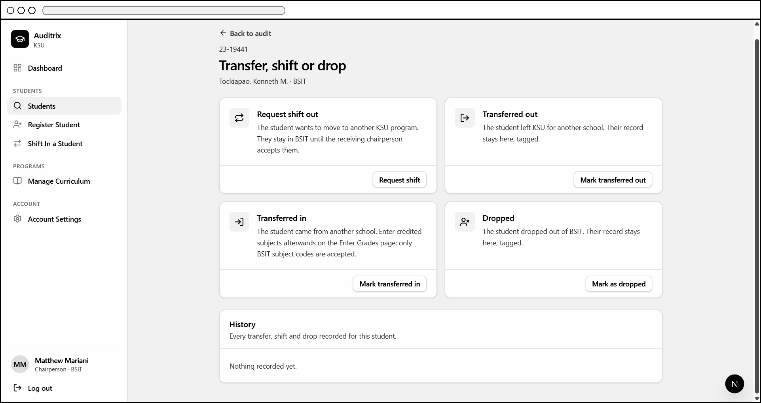
Figure 4.7e. Transfer / Shift Records
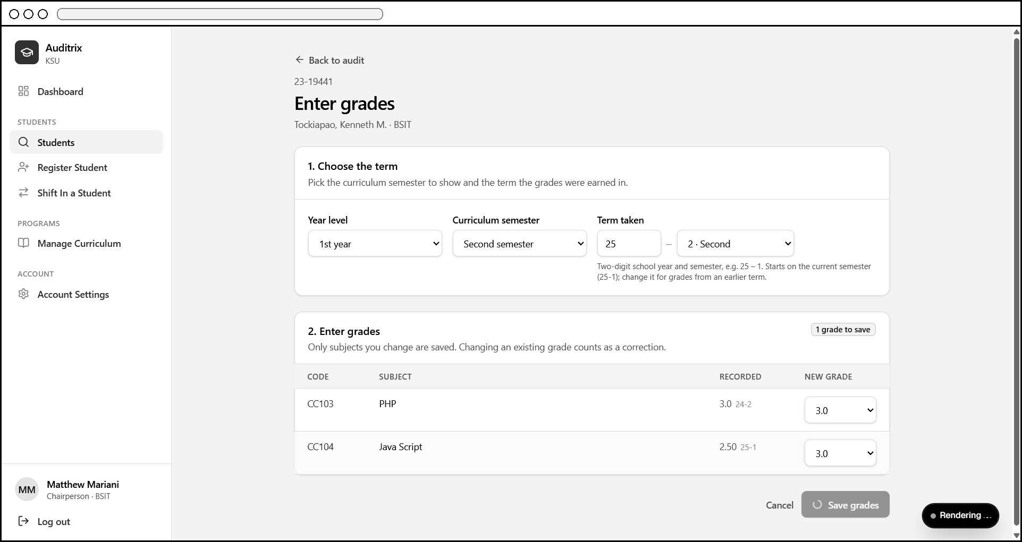
Figure 4.7f. Enter Grades — choosing the term
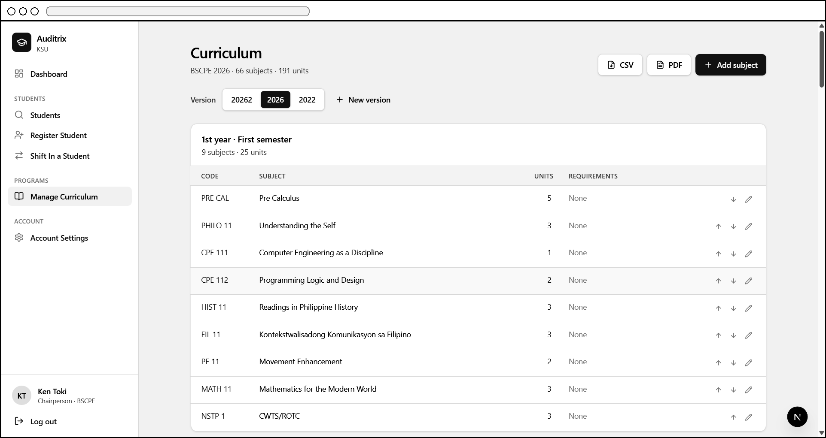
Figure 4.7g. Manage Curriculum Versions
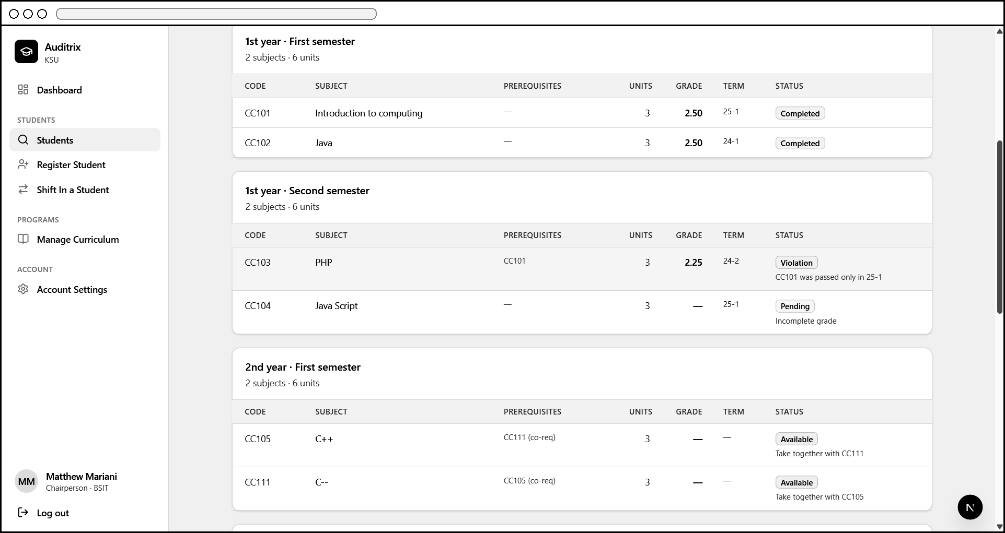
Figure 4.7h. Student Audit — status, term and reason for each subject
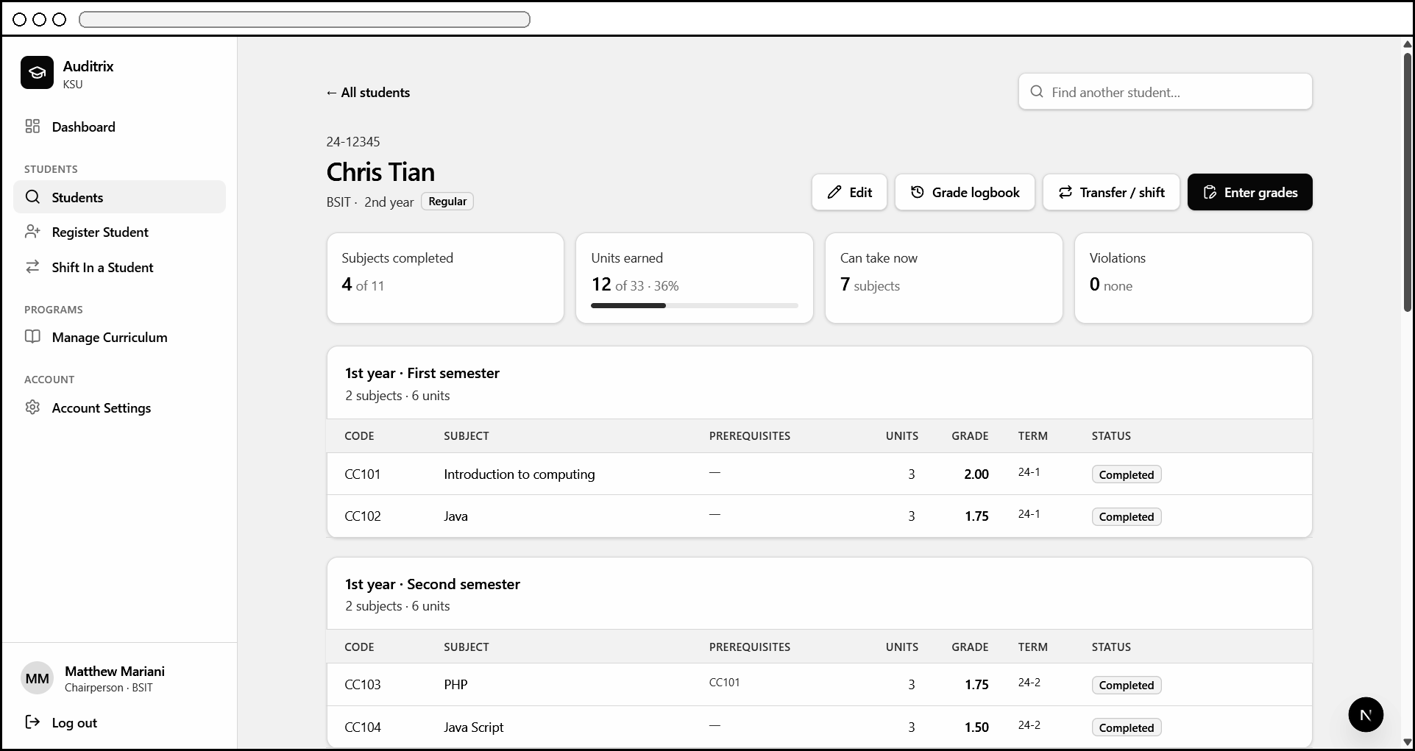
Figure 4.7i. Student Audit — fully compliant (Regular) example
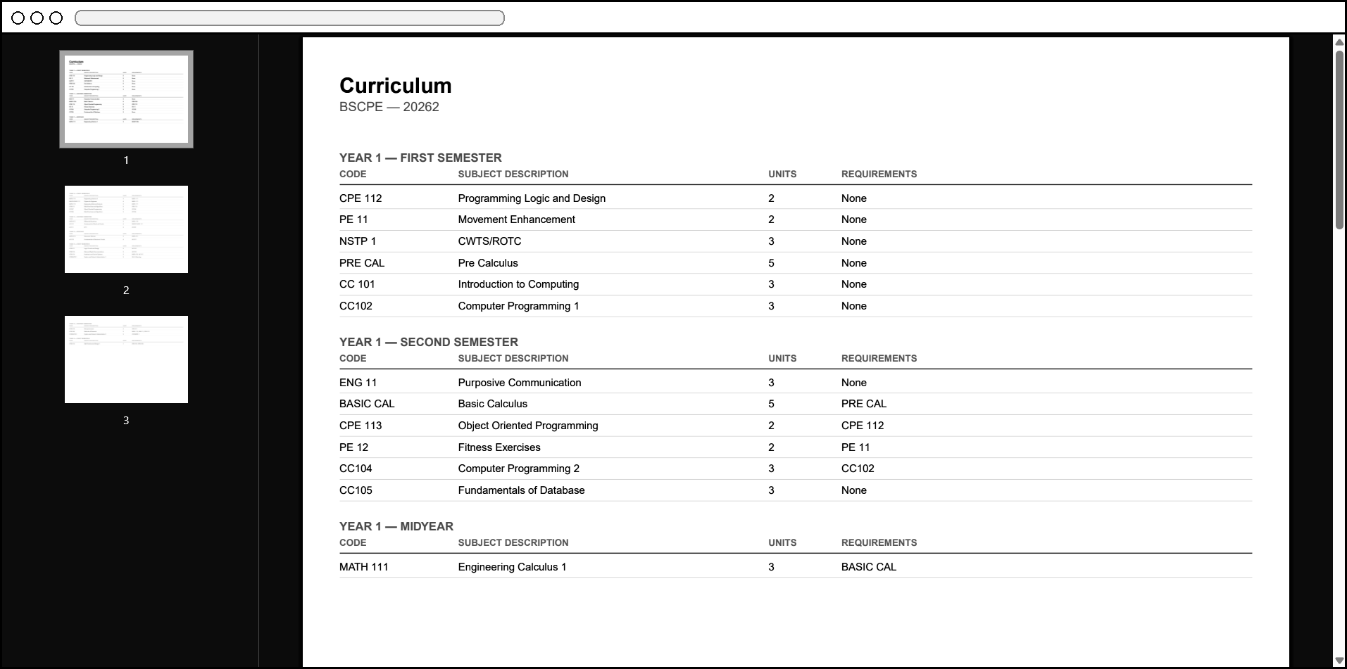
Figure 4.7j. Export Curriculum — PDF output
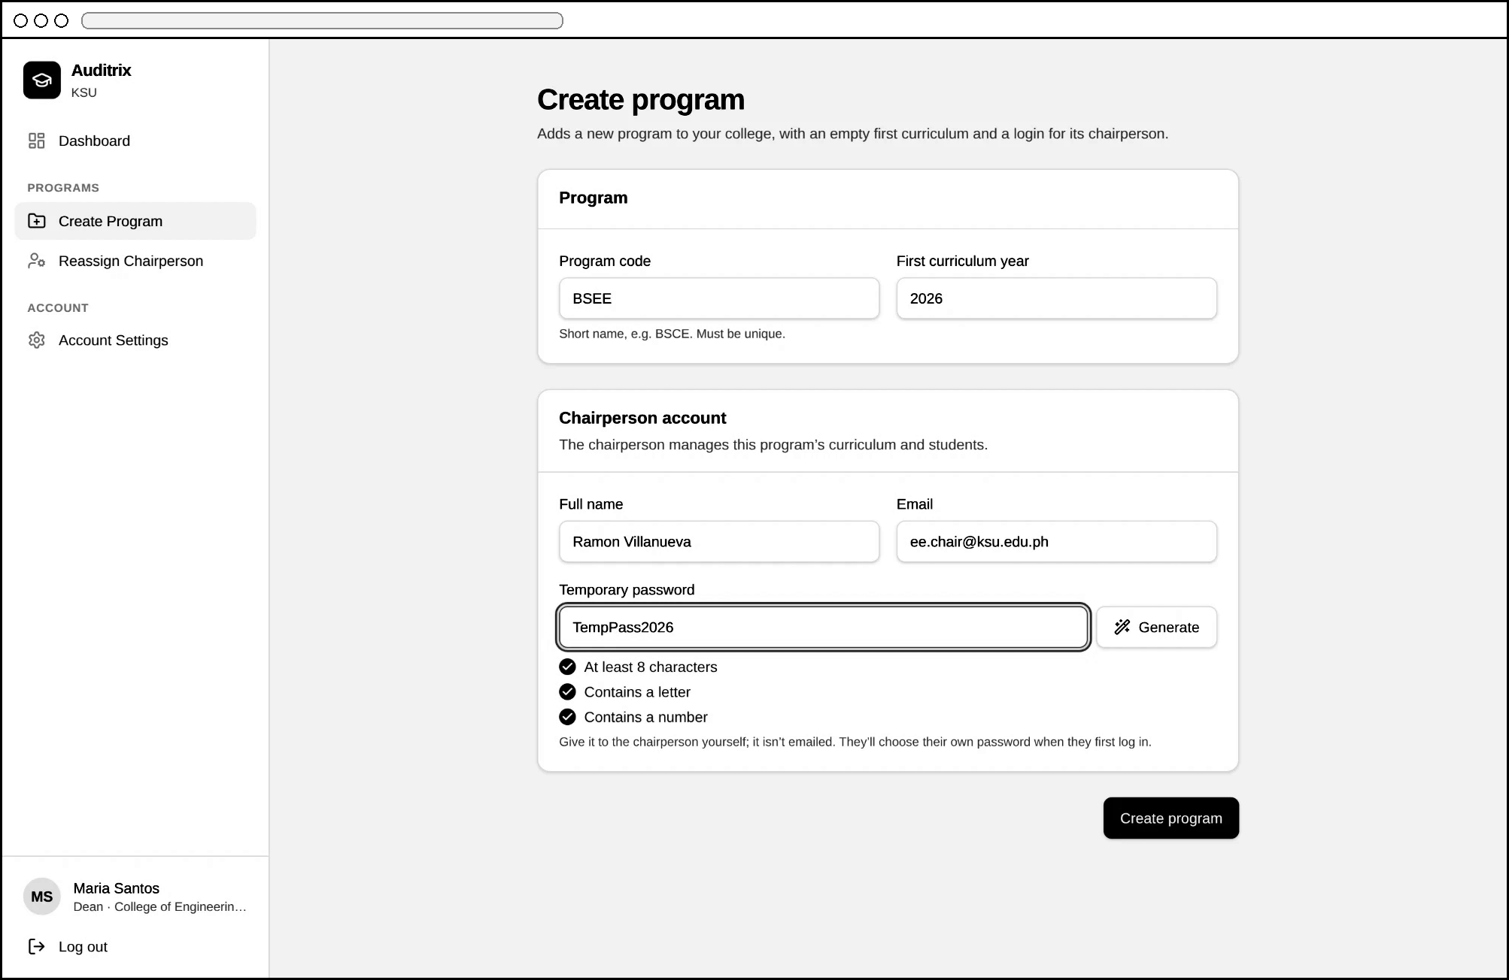
Figure 4.7k. Create Program — new chairperson account with a temporary password
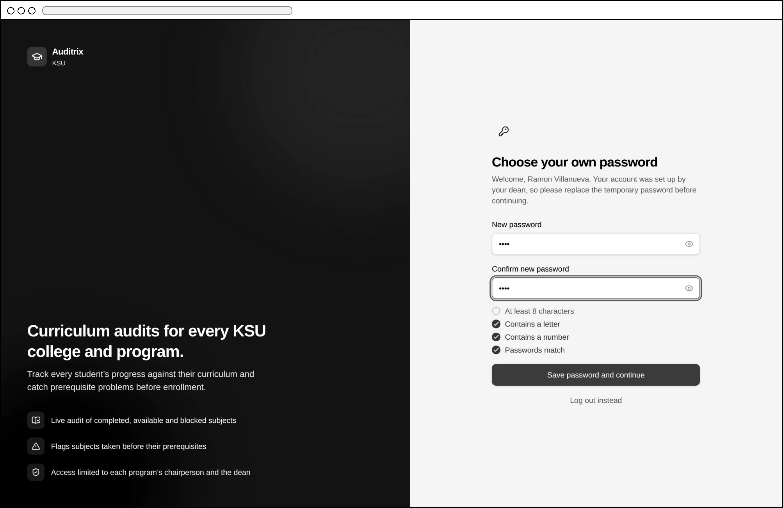
Figure 4.7l. First Log In — password change with the rules checklist
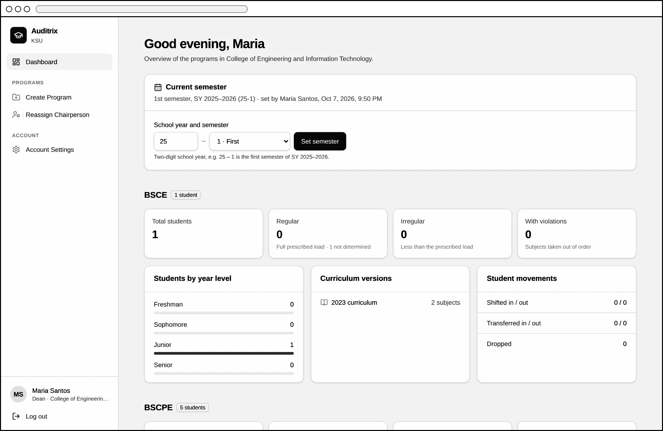
Figure 4.7m. Dean Dashboard — Current semester
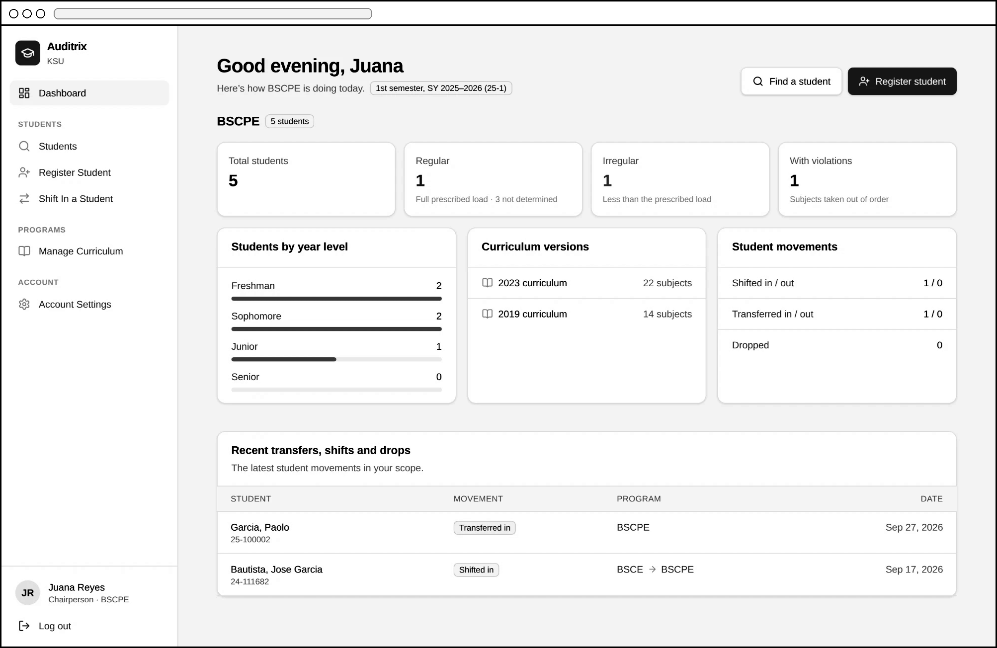
Figure 4.7n. Chairperson Dashboard
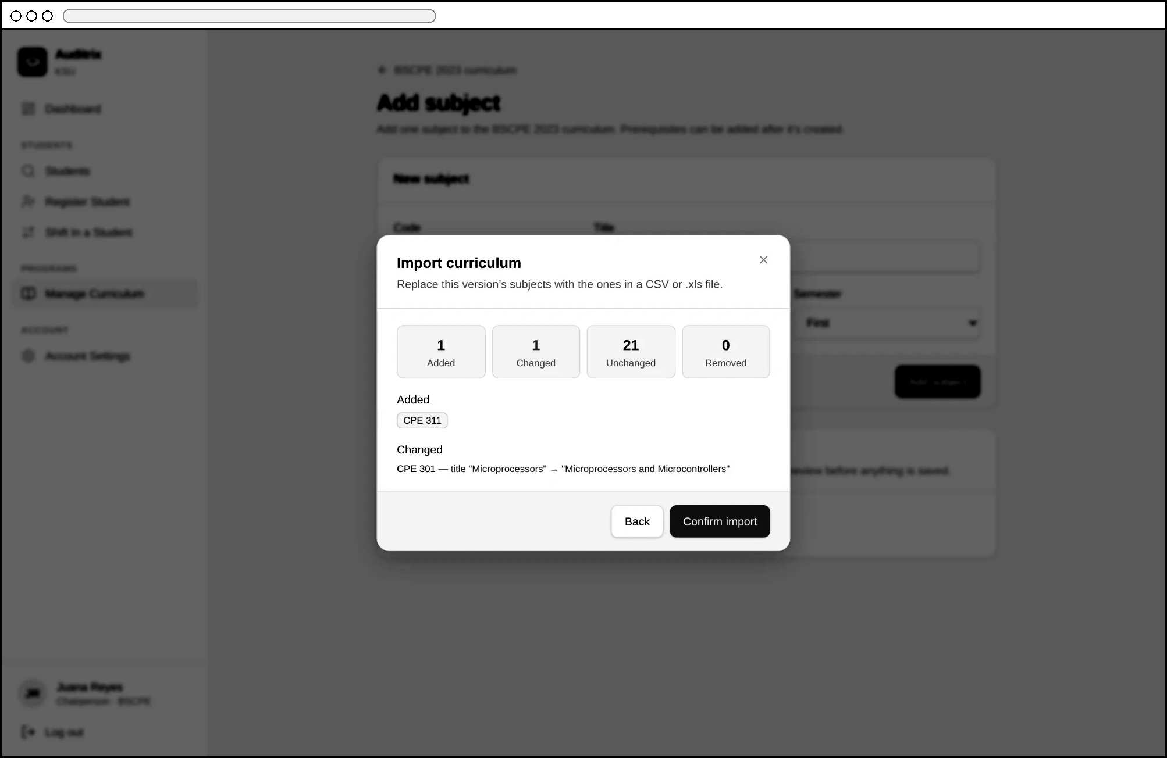
Figure 4.7o. Import Curriculum — preview of changes
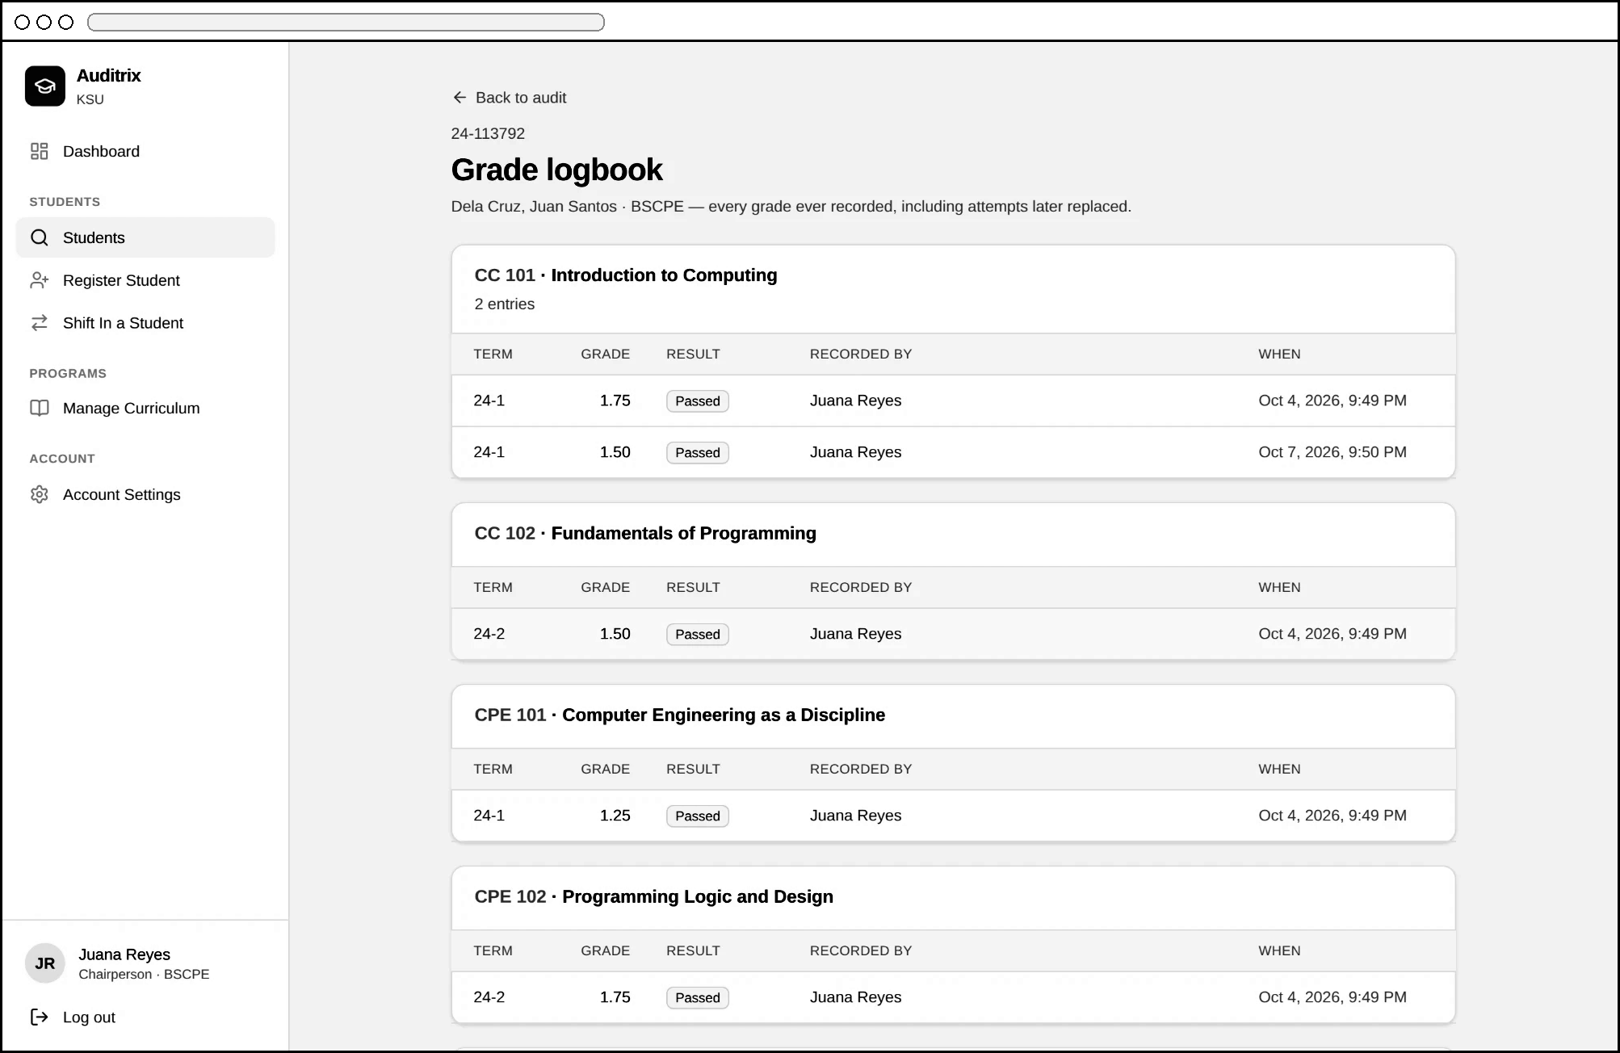
Figure 4.7p. Grade Logbook
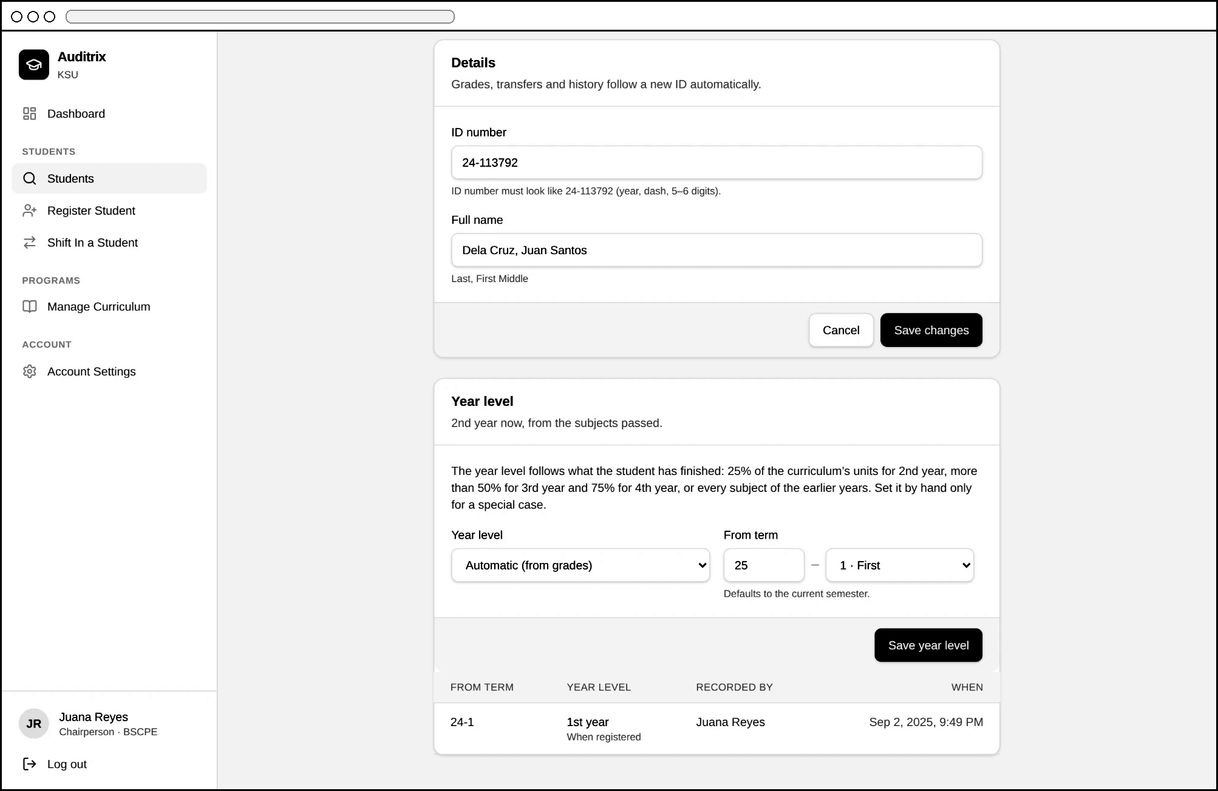
Figure 4.7q. Edit Student — year level (automatic or set by hand)
Non-Functional Requirements of the Proposed System
- Functional Suitability: the Audit Engine implements the prerequisite, co-requisite, year-standing and "all subjects completed" rules of the KSU Student Handbook and Operations Manual, verified by 163 automated tests.
- Reliability: audit results are worked out from the terms every time, so they do not depend on the order of grade entry; invalid grades, terms, ID numbers and import files are rejected with a reason, and curriculum imports are previewed before saving; the database itself refuses grades that are not KSU grades and changes to locked records.
- Performance Efficiency: the audit is computed when a student's page or the dashboard is opened, so results are current as soon as grades are saved.
- Usability and Security: the interface uses one consistent design with confirmation dialogs and notifications; access is role-scoped via RLS, and new chairpersons must replace their temporary password at first login; every page checks the user's role, users are signed out after 30 minutes without activity, and an account is blocked for 15 minutes after five wrong passwords.
- Maintainability: curriculum versioning allows new curriculum years to be added without altering audit logic for existing cohorts; the audit rules are kept in a separate, tested module, and each database change has an undo script.
- Portability/Compatibility: delivered as a responsive web application accessible across desktop, tablet, and smartphone browsers.

Functional testing. The researchers scripted a web browser with Playwright against a local copy of the full system (the PostgreSQL database and the application) loaded with sample CEIT data, logging in as a dean and as chairpersons and going through each feature: violations and their reasons, INC completion, the out-of-order warning after saving grades, setting the current semester, automatic year levels moving up with grades and semesters, chairperson overrides, regular and irregular counts, .xls and .xlsx imports, the earlier-term warning, and the password checklist. All scenarios passed after the defects found were fixed.
A problem found and fixed. The first version of the prerequisite checker decided, at the moment a grade was typed in, whether the prerequisites were already in the database, and stored the result as a permanent "invalid entry" flag. Testing showed that this gave wrong results in five situations:
- grades entered out of order (e.g., second-semester grades before first-semester grades) were wrongly flagged;
- a prerequisite passed only in a later term was not caught if it happened to be entered first;
- same-term prerequisite violations were caught or missed depending on the order of the rows;
- co-requisite results depended on the order of entry; and
- re-saving a flagged grade after the prerequisite was entered erased the violation.
The checker was therefore redesigned to work from the terms: it compares the term each subject was taken with the term each requirement was passed, every time the audit is shown. The result no longer depends on the order in which grades are entered, and each of the five situations above is now covered by an automated test. This experience shows why a curriculum audit should be based on when subjects were taken rather than on when their grades were encoded: in practice, the grades of existing students are often encoded long after the terms in which they were earned.
Extent of Compliance of the Proposed System (SOP No. 4)
Upon completion of the system, Auditrix is to be evaluated by the Program Chairpersons and selected IT experts using a printed (paper-based) questionnaire built on the ISO/IEC 25010 software quality model, with each characteristic mapped to a specific part of the system. Responses will be analyzed using the Weighted Mean. Table 4.4 will present the extent of compliance per quality characteristic.
Quality Characteristic | System Component Evaluated | Weighted Mean | Verbal Interpretation
Functional Suitability | Audit Engine / grade entry and violation flagging | [insert] | [insert]
Reliability | Consistent audit results / validated imports | [insert] | [insert]
Performance Efficiency | Audit and dashboard loading time | [insert] | [insert]
Usability | Dashboard and student audit page | [insert] | [insert]
Security | RLS access control / password policy | [insert] | [insert]
Compatibility | Cross-device responsiveness | [insert] | [insert]
Maintainability | Curriculum versioning / modular audit rules | [insert] | [insert]
Portability | Web-based accessibility | [insert] | [insert]
Safety | Data integrity / confirmations / access safeguards | [insert] | [insert]
Table 4.4. Extent of Compliance of Auditrix with ISO/IEC 25010
References
Alugar, R., & Itaas, E. (2021).
Exploring the implementation of curriculum quality audit in a Philippine State University. International Journal of Curriculum and Instruction, 13(2), 1620–1639.
Espinosa, G., Serrano, M., & Balmes, H. (2024).
Automated enrollment queueing system in a university towards student experience and operational efficiency. Philippine E-Journals.
Halover, E., & Manuel, M. (2021).
Academic program audit: A quality assurance mechanism for higher education programs in the University of Baguio. University of Baguio Research Journal, 45(2).
Largoza, G., & Fernandez, C. (2025).
Review of CHED policies, standards, and guidelines (PSGs) pre- and post-K to 12 reforms. Philippine Institute for Development Studies, Discussion Paper Series No. 2025-13.
Smith, R. (2020).
Degree audit systems and student success. Journal of Higher Education Policy and Management, 42(5), 512–528.
Laudon, K. C., & Laudon, J. P. (2022).
Management Information Systems: Managing the Digital Firm (17th ed.). Pearson.
Miña, L. M., Bercasio, R. R. O., & Llenaresas, H. M. (2021). Outcomes-based curricular review of a graduate program using curriculum quality audit methodology. BU R&D Journal, 24(1), 82–93.
Bagacay, I. R. V., Talatala, E. A., & Soberano, K. T. (2024). Streamlining school registration: An innovative automated system for registrars. International Journal of Computer Science and Mobile Computing, 13(4), 1–5.
ISO. (2023).
ISO/IEC 25010:2023 Systems and software engineering — Systems and software Quality Requirements and Evaluation (SQuaRE) — Product quality model. International Organization for Standardization.
Akari Software. (2023).
A buyer's guide to curriculum management software. https://akarisoftware.com/curriculum-management-software- guide/
Akulova, B., Tashtobaeva, B., Vassilev, T., & Koychumanov, B. (2025).
Development of an information system for accreditation and assessment in education. In 2025 International Conference on Algorithms, Computing and Informatics (ICAI).
IEEE. https://doi.org/10.1109/ICAI63830.2025.00045
Al-Fedaghi, S., & Al-Muhanna, A. (2022).
An online management system for streamlining and monitoring learning outcomes assessment. Education and Information Technologies, 27(1), 1269-1292. https://doi.org/10.1007/s10639-021-10650-3
Gunawan, A., Gunadi, I. G. A., & Dewi, L. J. E. (2023). Development of a web-based dashboard system for monitoring study programme accreditation instruments. Sinkron: Jurnal dan Penelitian Teknik Informatika, 8(3), 1917-1926. https://doi.org/10.33395/sinkron.v8i3.12799
Jovanović, M., & Dimitrijević, D. (2023).
Higher education curriculum management system. Fact a Universitatis, Series: Teaching, Learning and Teacher Education,7(2),165-178. https://doi.org/10.22190/FUTLTeD2302165J
Mohale, M. A. (2023).
Community engagement in higher education: Developments after the first institutional audit cycle. South African Journal of Higher Education, 37(1), 1-18. https://doi.org/10.20853/37-1-5675
Naldi, A., Nurkadri, N., Srisudarso, M., & Pratama, I. G. L. (2024).
Evaluation of the effectiveness of artificial intelligence system in higher education curriculum management. Journal of Educational Research and Evaluation,8(1),45-58. https://doi.org/10.23887/jere.v8i1.12345
Oware, E. N., & Mokoena, S. (2025).
Standardized framework for institutional audit for quality in Ghanaian Universities. Frontiers in Education, 10, 1673932. https://doi.org/10.3389/feduc.2025.1673932
Quality Assurance Agency for Higher Education. (2024).
When quality assurance meets innovation in higher education:Case studies. QAA. https://www.qaa.ac.uk/membership/benefits-of-qaa- membership/collaborative-enhancement-projects
Sadhana, R., & Freire, A. (2025).
A web-based student learning outcome assessment system for secondary education: Design, development, and empirical evaluation. Ceddi Journal of Education, 4(2), 33-41. https://doi.org/10.56134/cje.v4i2.157
Saeed, S., Almuhaideb, A. M., Bamarouf, Y. A., & Al-Malaise Al-Ghamdi, A. (2021).
Sustainable program assessment practices: A review of the ABET and NCAAA computer information systems accreditation process. International Journal of Environmental Research and Public Health, 18(23), 12691. https://doi.org/10.3390/ijerph182312691
Salleh, S. F., Ujir, H., Sapawi, R., & Hashim, H. F. (2020). Accreditation document tracking system using Scrum approach. International Journal of Evaluation and Research in Education, 9(1), 153-161. https://doi.org/10.11591/ijere.v9i1.20418
Taufiqurrahman, Junaedy, & Syarifuddin, R. (2025). Development of a web-based accreditation system for study program management using the Waterfall model. Nusantara Journal of Artificial Intelligence and Information Systems, 1(2), 59-66. https://doi.org/10.47776/nuai.v1i2.1663
Watermark. (2025).
Planning & Self-Study: Assessment and accreditation software. https://www.watermarkinsights.com/solutions/planning-self-study/
Xiaoyan, W., Azam, S. M. F., & Tham, J. (2023).
Sustainable higher education curriculum management system in China: Theoretical perspectives. European Journal of Management and Marketing Studies, 8(2), 1-15. https://doi.org/10.46827/ejmms.v8i2.1441
Briones, M. C. B. (2019).
Implementation of Outcomes Based Education in State Universities in Region I. Southeast Asian Journal of Science and Technology, 4(1), 1-12. https://www.sajst.org/online/index.php/sajst/article/view/157
Commission on Higher Education. (2014).
Handbook on typology, outcomes-based education, and institutional sustainability assessment. CHED. http://www.pnuresearchportal.org/wp-content/uploads/2015/08/Handbook-on-Typology-Outcomes.pdf
Commission on Higher Education. (2012).
CMO No. 46, Series of 2012: Policy-standard to enhance quality assurance (QA) in Philippine higher education. CHED.
Education Commission II. (2025).
EDCOM 2 final report: National Education and Workforce Development Plan (NatPlan) 2026-2035. Republic of the Philippines.
Guimaras State University. (2025).
Quality assurance framework and achievements. https://www.gsu.edu.ph/quality-assurance/
Miano, M. S. D., & Baguio, J. B. (2024).
Application of curriculum mapping in relation to classroom learning outcomes of public elementary schools. Asian Journal of Education and Social Studies, 50(11), 136-145. https://doi.org/10.9734/ajess/2024/v50/111641
Miranda, R. D., & Reyes-Chua, E. (2021).
Best practices in quality assurance in selected higher education institutions (HEIs) in the Philippines in the light of the Malcolm Baldrige framework. WSEAS Transactions on Environment and Development, 17, 115-125. https://doi.org/10.37394/232015.2021.17.11
Necosia, R. I. M. T., & Sealza, I. S. (2024).
Service quality assessment tool in a State University in Northern Mindanao. Journal of Interdisciplinary Perspectives, 8(1), 1-12. https://doi.org/10.69569/jip.2024.0036
Philippine Institute for Development Studies. (2024). Strengthening CHED's developmental and regulatory processes (Discussion Paper Series No. 2024-41). PIDS. https://pidswebs.pids.gov.ph/CDN/document/pidsdps2441.pdf
Prado, R. (2025).
Evaluation of the quality assurance practices of the College of Education programs of a Philippine local university. Journal of Interdisciplinary Perspectives, 9(1), 1-10. https://doi.org/10.69569/jip.2025.0042
Republic of the Philippines. (1982).
Batas Pambansa Blg. 232: Education Act of 1982.
Santelices, R., & De La Cruz, D. A. R. (2023).
Quality assurance in the certification procedure of the Regional Quality Assessment Team: The case of higher education institutions in Region V, Philippines. SSRN Electronic Journal. https://doi.org/10.2139/ssrn.4735068
Surigao State College of Technology. (2025).
General Education Program Curriculum Map: Outcomes-Based Education Framework. https://www.scribd.com/document/841955371/Final-OBE-PEO-Map-PO-Map-Curriculum-Map-Course-Outcome-Map-GenEd
World Bank. (2023). Digital transformation of Philippine higher education (Report No. P177574). World Bank Group. https://documents1.worldbank.org/curated/en/099925001062333685/pdf/P17757402843a10c90b3e30308406a38304.pdf
Kalinga State University. (2020). Student handbook (2020 ed.). Kalinga State University.
Kalinga State University. (n.d.). Operations manual: Student development services & placement guide. Kalinga State University.

